Job title: Head of Service Performance and Governance
Directorate/Service/Team: Children’s Directorate, Commissioning and Partnerships

Organisation structure
Reporting to: Corporate Director of Commissioning and Partnerships and Executive Director People- Children
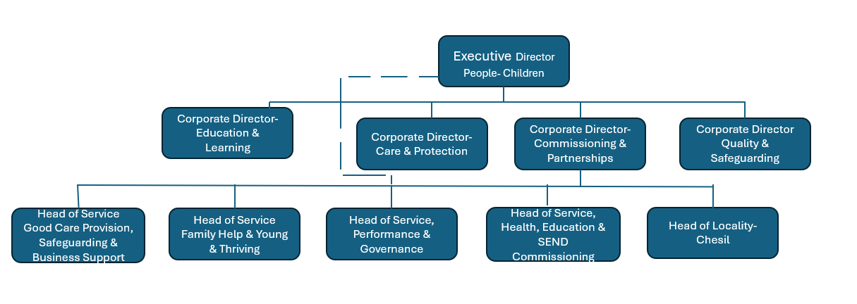

Responsibility for:
Strategic Leadership of System Change and Partnerships, Integration and Transformation Programmes and Performance and Corporate Governance.

Context of work
This post is created as part of our Commissioning & Partnerships Directorate reshape where we are investing in additional senior leadership and aligning Heads of Service alongside our challenges and priorities. This team brings together strategic partnerships and planning, work that underpins the Directorate and facilitates strategic partnership. This function ensures that the Directorate is well organised, oversees strategic co-ordination and ensures that there is synergy in strategic planning.

This role will play a crucial role in system leadership, partnership change and integration. Recognising the long- term benefits of working collaboratively, will forge and strengthen strategic partnerships across the Integrated Care Partnership. The post will strategically lead the Strategic Alliance for Children and Young People, co-ordinate the Board, drive forward the Children, Young People and Families Plan priorities with partners, identifying areas of improvement and change, and collaboratively remedying areas of focus. You will be responsible for leading planning for key strategic partnership events.

You will be responsible for supporting the Executive Director of People- Children’s in oversight of the delivery of Statutory Children’s Services Duties, identifying areas of national policy change or responsibilities and implementing changes locally. You will lead the Directorate in ensuring that there are robust governance frameworks are in place. This post will act as an interface between Corporate Services, the Corporate Plan and identify linkages that require a response by the Children’s Directorate. You will provide a directorate link with Corporate Finance and Governance.
This post will work closely with the Corporate Directors and have oversight and strategic leadership of transformation projects, horizon scanning opportunities for transformation, bids, investment and identifying emerging practice and providing advice on benefits and associated risks. You will work with Corporate Directors to identify areas of improvement. You will be a strategic link to initiatives of DfE and national regional Association of Directors of Children’s Services, (ADCS).
Children's Services Senior Leadership Team (CSLT) Meetings and extended CLST (XCSLT) and ‘away days’ and workshops will be within the remit of this role, agenda planning, co-ordination and evaluation of outcomes. The post will lead on Children’s Directorate governance, including governance frameworks, external audit (SWAP) audit co-ordination, Freedom of Information Requests, business continuity, maintenance of risk registers, delegation and scheme of nomination, research and ethics. You will lead co-ordination of the elected members development programme for the Children’s Directorate.
The role will provide strategic leadership of the dedicated Children’s Performance team, enabling a performance and outcome led Service and ensuring statutory reporting is accurate and timely with strong system links to shared data platforms. You will provide strategic direction for transformation programmes, investments and associated savings. You will lead design and implementation of transformation and pilots for Children’s services. A robust understanding of performance data will be required to evaluate and monitor the success of initiatives, pilots and transformation programmes. If transformation programmes become embedded business as usual the role lead the planning of effective handover to operational or commissioning services to enable the transformation team to flex and expand and retract as needed to develop new initiatives as they emerge.
Children’s Digital Transformation and digitial commissioning sits in this portfolio, enabling development of our digital family offer and internal systems development. This post will be responsible for successful completion and continous improvement of internal business processes, aligning with our transformation programmes.

Travel requirement.

This position does not have significant travel requirements. There may be a requirement to on occasion to be available to travel across the County.

Other information

The ability to converse at ease with customers and provide advice in accurate spoken English is essential for this post. This requires a current DBS clearance and an appropriate qualification, with professional registration where this applies.

Context statement prepared by:
Manager | Helen Mason | Date | July 2024

