Job title: Head of Commissioning of Family Help and Young and thriving
Directorate/Service/Team: Children’s Directorate, Commissioning and Partnerships

Organisation structure
Reporting to: Corporate Director of Commissioning and Partnerships

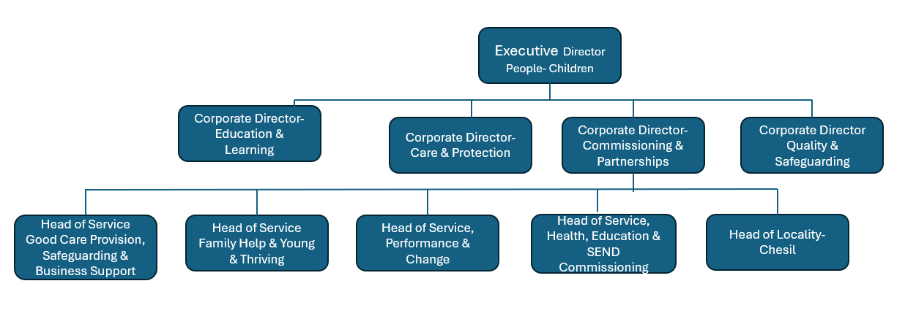
Responsibility for:
Strategic leadership, management and contribution to the following ambitions in our Dorset Children, Young People and Families Plan 2023-2033; Best Start in Life, Young and Thriving and Commissioning that supports Local Family Help.

Context of work
This post is created as part of our Commissioning & Partnerships Directorate reshape where we are investing in additional senior leadership and aligning Heads of Service alongside our challenges and priorities. This service area brings together policy expertise and strategic leadership in commissioning and operational functions across early years, children, young people and families.

The position will be responsible for the following staff and services:

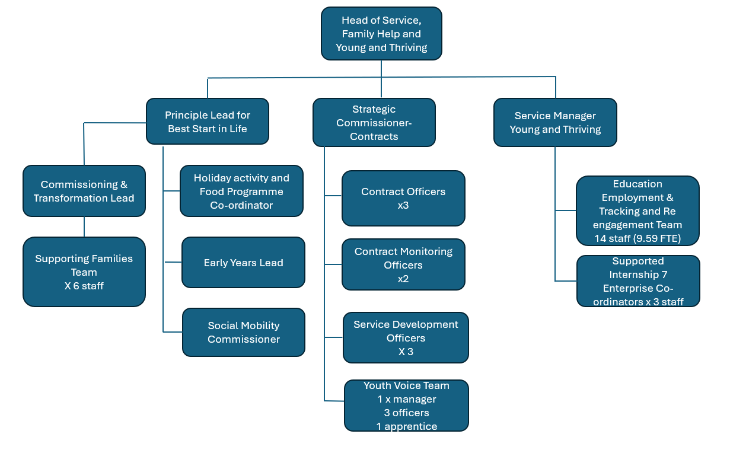

As with our Families First for Children Pathfinder approach we continue to focus on collaborative early help offer within our Locality Model, you will be responsible for the commissioned provision to support families. You will lead the development of an Early Help Strategy, that will be co-produced and co-ordinated, and effectively implemented. This will align and sit alongside our Kinship Strategy and contribute to the Pathfinder Families First model of local delivery. This will entail collaborative working with VCSE, Local Alliance Groups and social care operational leads and Heads of Locality to understand the existing offer and gaps, consolidation or new commissioning arrangements.

The post will lead on Best Start in Life, including strategic leadership to the early years provider sector and LA led provision. Key to success will be the development of partnership co- produced Early Years Strategy that includes sufficiency, which sets out our ambitions for our young children.
Essential will be close parnership working with Public Health Dorset, Early Years Providers and Dorset Health Care for Public Health Nursing and Health visitor provision.

You will provide strategic leadership and ensure excellent service delivery of the Holiday and Activities Fund Programme (HAF), working with the VCSE so eligible school age children benefit from accessible enrichment activities and good nutrition through school holidays. You will lead the social mobility agenda and delivery and strategically lead the development and implementation of Family Hubs. Dorset has received DfE Family Hub Transformation Programme 1 and we have additionally invested to commit to having at least one Family Hub in each of our localities by the end of 2024.

Our Safeguarding Families Together model is moving from pilot phase in 3 of our localities into whole Council area roll out, this role will be responsible for the continued implementation and delivery of this model, which will necessitate strong collaborative working across system partners.

As part of our early family help offer , you will be responsible for the government funded Supporting Families Programme, continuing our whole family working approach. You will provide strategic leadership, delivery and commissioning and operationalise our earned automony status, removing payment by results with all funding up front.

You will strategically lead our Young and Thriving agenda which will include leadership for the following functions:
- Implementation of the statutory duty to improve young people’s well being.
- Leadership for our well established youth voice team, engaging with care experienced Children and Young People.
- Education, Employment, Training Tracking and re Engagement Team
- Supported Internships and Enterprise Co-ordinators

This role will have strategic leadership of all Children’s contracting activity, as part of the commissioning cycle and will work closely with other Commissioning and Partnership Heads of Service to support their contract development, framework development and contract monitoring. You will provide leadership for the contracts team and oversee the contracts Pipeline and timely review of provision, supporting Children’s contracts, including brokered and block arrangements. You will work closely with central procurement leadership to fuflfill this function and align with corporate policy.

Travel requirement.

This position does not have significant travel requirements. There may be a requirement to on occasion to be available to travel across the County.

Other information

The ability to converse at ease with customers and provide advice in accurate spoken English is essential for this post. This requires a current DBS clearance and an appropriate qualification, with professional registration where this applies.

Context statement prepared by:
Manager | Helen Mason | Date | July 2024

