Job title: **Project Support Officer – Dorset National Landscape**

Directorate/Service/Team: Place / Environment and Wellbeing / Coast and Greenspace/ Dorset National Landscape team

**Organisation Structure**

Reporting to: **Sally King, Visitor Tourism and Access Manager**

Responsibility for:

The Dorset National Landscape Project Support Officer will be based within the National Landscape team structure, alongside two other officers reporting to the Visitor, Tourism and Access Manager, as outlined in the structure chart below. The team is hosted and line managed by Dorset Council.

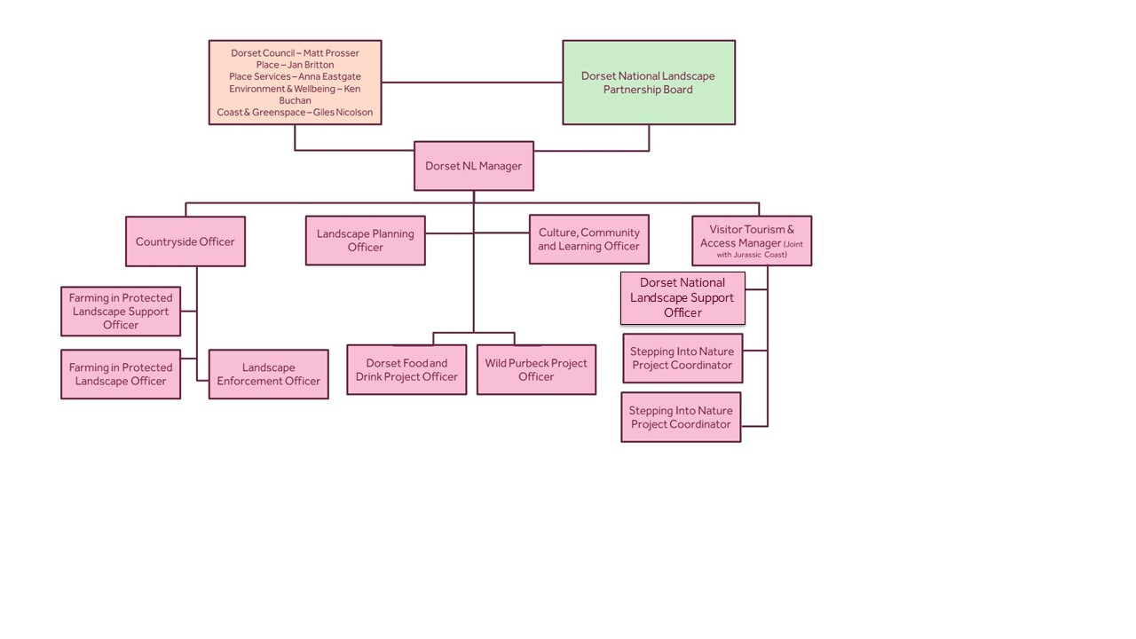

The Dorset National Landscape Team is the dedicated staff team for the Dorset National Landscape Partnership; a partnership which comprises Natural England, Dorset Council, various representatives of landowners, farmers, tourism providers, local communities, Jurassic Coast World Heritage Site and the biodiversity sector. The team is funded by Defra and the Local Authority listed above through a Memorandum of Agreement. The Dorset National Landscape Partnership is responsible for developing, reviewing and publishing a management plan which sets out a commitment to conserving and enhancing the area’s natural beauty for generations to come.

**Context of Work**

The focus of the Dorset National Landscape Project Support Officer will be:

* To provide general administrative support for the Dorset National Landscape Team and Partnership
* To assist team members and the Partnership with a variety of projects, helping to deliver the Dorset National Landscape Management Plan
* To provide support with financial management/ procurement and grant administration
* To assist in raising the awareness of Dorset National Landscape, and its special properties, amongst the general public and other stakeholders

In detail, the Dorset National Landscape Project Support Assistant role will:

1. Provide support for projects including, but not exclusively, community and public engagement, Dorset Fingerposts, Nature Calling, West Dorset Trees, Visitor Management and other projects as they are developed
2. Co-ordinate the Dorset National Landscape Fund
3. Provide support for finance, working with Dorset Council’s systems, to process payments, do procurement, manage subscriptions (eg mailchimp, canva)
4. Be a first point of contact for the team, deal effectively with incoming enquiries to the Dorset National Landscape from members of the public and external organisations face to face, via phone and email
5. Provide support for grant administration, which will differ from project to project, including help set up budget spreadsheets for new projects, and help set up admin systems for new and existing projects
6. Assist in the delivery of events, conferences and forums; including bookings, invites, help set up rooms / gazebo, manage practical logistics, and provide a warm welcome at events and meetings
7. Assist with communications, including updating the Dorset National Landscape website and helping with social media posts, editing images with Canva and maintaining the digital photo library. Assist in the promotion of projects and the Dorset National Landscape generally through public events
8. Manage and update databases as required
9. Help to organise Dorset National Landscape Partnership Board meetings and forums including sending out agendas, producing and circulating minutes. Help facilitate other meetings (e.g. project steering group meetings) including organising dates, note-taking, venue booking
10. Help organise in-person team meetings, book venues etc
11. Work occasional weekends and evenings at shows/events/meetings to represent and positively promote the Dorset National Landscape
12. To undertake any other duties commensurate with this post

**Travel Requirement**

This position has a significant travel requirement. This means that there is a requirement for a vehicle (or transport deemed to be suitable by the Council) to be available on most working days in order to carry out normal duties. Employees in positions with a significant travel requirement are required to provide a replacement vehicle if their usual vehicle is not available over an extended period.

**Other information**

* Full time (37 hours per week). Job share may be considered
* Fixed term contract until June 2026
* Largely home based, with the option of working from County Hall, Dorchester – and the need to travel throughout the Dorset National Landscape area for events and meetings
* Some outdoor/event work will be essential, requiring the ability to participate in a variety of activities in all weathers, lifting and carrying of materials and requiring the ability to travel to all parts of the DNL
* The ability to converse at ease with the public and provide advice in accurate spoken English is essential for the post.

|  |  |  |  |
| --- | --- | --- | --- |
| **Context statement prepared by:** | | | |
| Manager | Sally King | Date | 07.10.2024 |