Job title: Arboriculture and Grounds Team manager

Directorate/Service/Team: Place Services, Waste and Greenspace, Env and Greenspace

Organisation Structure

This post is within the Waste and Greenspace team in DC Place services.

Reporting to: Service Manager – Environment and Greenspace

Responsibility: Manage and develop the Arb and Grounds service for DC.

The Waste and Greenspace Service, includes:

- Waste Services
Dorset Council’s Waste Services team is responsible for a comprehensive set of statutory and operational waste functions. These include:
Household Waste & Recycling
- Kerbside collection and disposal of household waste and recycling under the Recycle for Dorset service.
Garden Waste
- Collection and disposal of garden waste for households subscribed to the service.
Recycling Infrastructure
- Mini recycling centres (bring banks) for items not collected at the kerbside.
- Household Recycling Centres (HRCs) – owned by Dorset Council and operated by a contractor.
Commercial Waste
- Tailored business waste and recycling services for schools and local businesses.
Street Cleansing
- Street cleaning and litter management, including investigation of littering offences.
Other Customer-Facing Waste Services
- Missed bin reporting, replacement bin requests, bulky waste collections, clinical waste support, and capacity adjustments (e.g., medical or large household needs).

- Fleet Servies – maintaining and managing DC Fleet of vehicles
- Maintenance and repair of DC vehicles
- Procurement and purchasing
- Maintain O licence
3. Environment and Greenspace Services (Env & Greenspace Operations)
Dorset Council’s Env and Greenspace Service manage a large and diverse range of countryside, coast, highway and public places. This includes:

Countryside & Park Sites
- Management of 80+ countryside sites, including:
  - A National Nature Reserve
  - 4 x Country parks
  - Visitor centres
  - SSSIs and Green Flag Award-winning open spaces
Public Rights of Way (PRoW)
- Maintenance of nearly 3,000 miles of Public Rights of Way, including footpaths, bridleways, and byways.
National Trails
- Oversight of long-distance trails such as:
  - Wessex Ridgeway
  - South West Coast Path
Highway Verges
- Management of almost 5,000 miles of highway verge, balancing:
  - Safety
  - Biodiversity
  - Landscape quality
Gypsy & Traveller Services
- Operating four permanent Traveller sites
- Managing unauthorised encampments
Grounds and Arboriculture, to manage and maintain:

- 250,000 highway trees – operational practical management, inspections and record keeping.
- Tree management, inspections and record keeping for DC landholdings, SLA’s and external contracts.
- 18-hole golf course and sports pitch maintenance
- 400+ contracts / SLA’s for Grounds maintenance for public organisations, e.g. schools, extremal and internal customers.
- Landscaping team – delivering capital projects for public bodies.

Context of Work - Environment and Greenspace

The Environment and Greenspace Service (EGS) include 4 distinct services:

- Greenspace (including rights of way, highway verge and countryside sites)
- Country Parks
- Arbs and Grounds
- Gypsy and Traveller

What are the key priorities for the Env and Greenspace team?
- The effective management and enhancement of highway verges
- The effective management and enhancement of the Southwest Coast Path, rights of way and trailways
- The practical management of DC / Highway trees to a high standard
- The surveying and recording of DC / Highway trees
- The effective delivery of grounds maintenance, sport turf management and landscaping projects.
- The effective management and enhancement of Dorset Council’s countryside infrastructure, particularly the Country Parks and wider sites.
- The effective management and delivery of income generating external and internal contracts and SLA’s.
- Maximising income through SLA’s and fee-paying work and external funding.
- Contributing to DC objectives such as the nature and climate emergency, healthy communities and supporting the Dorset economy.
- Ensure the highest standards of health and safety and best practice.
- Optimise budget and working practices to improve productivity and efficiency.

Who are the key people the team work with?
- General Public
- Town and Parish Council’s
- Volunteers and stakeholder groups
- DC Highway Community Officers
- Gypsy & Traveller communities and their representatives
- Third sector, government agencies, charities, and funding bodies
- Dorset Council teams and services across all directorates
- Contractors
- Cllrs and other elected representatives

The Arboriculture and Grounds Manager post. Pay grade G13 is countywide and sits within Environment and Greenspace Service.
The structure of the team is below. Some boxes represent multiple posts. A team of 46 staff in total.
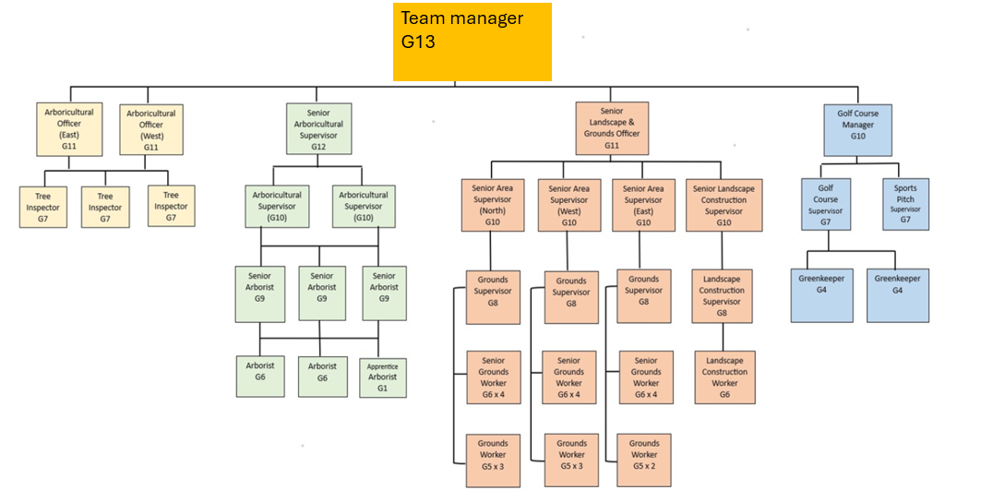
The Role: Arb and Grounds team manager

The purpose of the post is:

1. To lead and manage practical and technical staff delivering across the Grounds and Arbs service to meet required outcomes.
2. To assist the Service Manager in the strategic development, planning and delivery of
services within the Grounds and Arbs teams.
3. To be the Dorset Council representative for Arboriculture. This may include - prepare and give evidence as required in public enquiries, arbitrations and courts where appropriate.
4. To work proactively to provide advice and guidance on service-related issues to
elected members, service users, partners, the community and other stakeholders.
5. To identify opportunities and options for service development to meet agreed
outcomes.
6. To efficiently and effectively manage all available resources across Grounds and Arbs
services.
7. To deliver high standards of performance against national, corporate and service
specific performance indicators.
8. To manage the Grounds and Arbs teams and be accountable for allocated service
area.
9. To manage, coach and develop staff in accordance with the Council’s people
management standards and policies.
10. To identify and deliver opportunities for service and policy development within areas of
work including opportunities for co-production with partners, volunteers and the
community.
11. To prepare, consult upon and present business cases, equality impact assessments
and committee and other reports in respect of service and policy developments.
12. To lead on in the development of services and review of policies as directed by the
Head of Service and/or Service Manager
13. To lead, plan and implement the delivery of projects as required within areas of
responsibility.
14. To forecast, monitor and manage financial resources and budgets within allocated
areas of responsibility including managing funding streams, income generation or the
delivery of cost efficiencies.
15. To review commissioning, procurement and contracting strategies and processes as
relevant to the Grounds and Arbs service.
16. To undertake business reviews and the development of business plans for the
Grounds and Arbs service.
17. To contribute to service planning and take responsibility for the delivery of outcomes
through leadership and operational management of the Grounds and Arbs service.
18. To ensure that relevant statutory, legal, regulatory, safeguarding and policy
requirements are met within the allocated area of service responsibility.
19. To promote and manage engagement and consultation with service users and the
community including Town and Parish councils and interest groups, elected members,
partners and other stakeholders.
20. To take responsibility for health and safety within the allocated areas of responsibility
ensuring safe systems of work for staff, volunteers and the public.
21. To represent the Council as required at local, regional, or national meetings and
events or in dealing with media enquiries.
22.Any other lesser or comparable duties as required.

NB: The duties and responsibilities of this post are not restrictive, and the post holder may be required on occasion to undertake other duties. This will not substantially change the nature of the post.

Supervision and management
23. Reporting to: Service Manager for Env and Greenspace
24. Required to manage groups of staff within the Grounds and Arbs teams.

Other factors
25. To be responsible for technical equipment, purchasing and procurement as connected with the Grounds and Arbs service.
26. To be responsible for the effective management and development of systems to
handle Group data and data held on behalf of others e.g. Confirm, Ezy tree.
27. Primarily office-based post with regular travel to attend meetings, events and site visits
locally, regionally and nationally and sometimes under adverse weather and
hazardous site conditions.
28. Out of hours working to meet the requirements of the post.
29. Required to attend potentially challenging public meetings, inquiries and partnership
meetings.
30. Will be operating in a fast-changing environment and therefore subject to frequently
changing problems and circumstances.
31. Adhere to Dorset council behaviours and values.

Travel Requirement

This position has a significant travel requirement. This means that there is a requirement for a vehicle (or transport deemed to be suitable by the Council) to be available on most working days in order to carry out normal duties. Employees in positions with a significant travel requirement are required to provide a replacement vehicle if their usual vehicle is not available over an extended period.

Context statement prepared by:
Manager | Giles Nicholson | Date | 6th January 2026

