Context statement

Job title: Project Archivist (Past Lives, Future Proofed Project)
Directorate/Service/Team: Legal and Democratic Services / Archives and Records / Dorset History Centre

Organisation structure
Reporting to: Principal Archivist
Responsibility for: Project volunteers

This post is part of a project funded by National Lottery Heritage Fund. The 18-month Development Phase of the project involves piloting, evaluating and refining activities and preparing for a Stage 2 submission to NLHF.

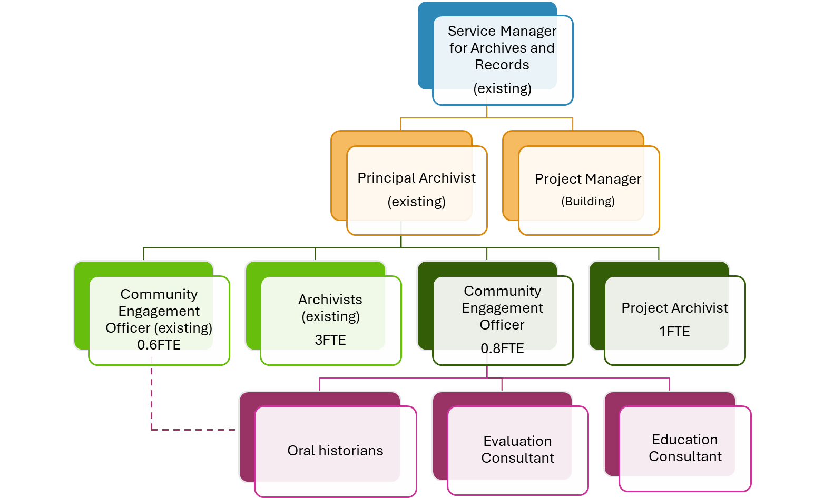

Context of work
Dorset History Centre is the principal archive repository and local studies collection for the county of Dorset, preserving over 1,000 years of history. We are ambitious to grow both our physical storage capacity (now at over 96% capacity) and our audiences for the future. We want to widen and diversify our holdings, ensuring that our collections are more representative of communities in Dorset today. We aim to increase knowledge and skills relating to archives across the county, raising standards in the acquisition and preservation of oral histories and in digital preservation, ensuring that heritage at risk of being lost forever is preserved for the future.

Our Heritage Funded project, Past Lives, Future Proofed, has a development phase running from April 2026 – September 2027. This role arises from the Action Plan for this phase.

The Project Archivist will work under the direction and management of the Principal Archivist with appropriate support where required from other project and permanent DHC staff. The post holder (18 months, full time [37 hours]) will work on piloting aspects of Past Lives, Future Proofed to ensure that the proposed approach is feasible and appropriate. The five activity strands are:
- Digital Leader: working with community organisations to increase knowledge and skills in oral history and digital preservation
- Mind the Gaps: improving the equity, diversity and inclusion of collections held by Dorset History Centre through partnership with local communities
- Archives for Arts’ Sake: adding to internationally important collections of artists' and creatives' archives and provide opportunities for meaningful participation
- Life and Crimes: working to conserve, index and digitise records of the court of Quarter Sessions for Dorset, with the help of volunteers

The post holder will work across all of these strands, and the evidence and information gained will directly inform the Stage 2 submission to Heritage Fund.

Duties will include:

- Accessioning and cataloguing of digital and hard copy archives using Epexio software
- Supervising volunteers working to list various collections, including a sample from the Quarter Sessions collection and Poole Lighthouse collection
- Collaborating with museums and community history organisations to develop knowledge and skills sharing activities
- Ensuring that statistics and other useful data relating to the project are collated
- Close working with Project and DHC colleagues to ensure the most efficient and practical approaches to the project;
- Assisting with marketing and publicity pertaining to the project.
- Contributing to project evaluation activities.
- Any other duties relating to Past Lives, Future Proofed as required.

The post holder will ideally have experience of cataloguing large, complex archive collections and will be familiar with using archival cataloguing software, such as Epexio. Knowledge of Quarter Session archives would be an advantage but is not essential. The post holder will have opportunities to work with colleagues across DHC to enhance their knowledge of this busy archive service and the various functions that it performs.

Travel requirement
This position has no significant travel requirement although occasional travel may be required at times, for example to and from The Lighthouse, Poole.

Other information
The ability to converse at ease with customers and provide advice in accurate spoken English is essential for the post.

Context statement prepared by:
Manager | Service Manager for Archives and Records | Date | October 2025

