

To accompany job description and person specification when required

Job title: Grade 16: Operations Manager (Residential and outreach/ edge of care services)

Directorate/Service/Team: Children in Care

Organisation Structure
Reporting to: Head of Service and Responsible Individual
Responsibility for: Leadership and management for services.
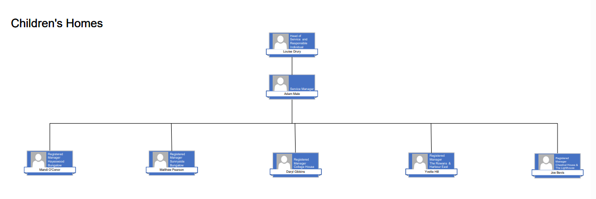

Context of Work
- The focus of the work is to provide leadership for residential and outreach services, ensuring compliances with The Children’s Homes Regulations 2015 for those services registered with Ofsted.
- To register as the Responsible Individual with Ofsted and support a positive and professional relationship with the regulator.
- To support managers with any safeguarding concerns or referrals to LADO and ensure correct reporting under the regulatory framework.
- To provide supervision to the registered managers and matrix manage the clinicians and specialist roles
- Provide guidance and operational oversight as necessary outside normal office hours using on-call protocol and system.
- To complete investigations and provide reports where required.
- To provide guidance and support to all managers and teams in relation to regulatory compliance and to develop service provisions to strengthen inspection outcomes.
- To support services where they may incur barriers to providing a good service provision and escalate concerns to Head of Service.
- To be responsible for the overall planning and development of the workforce development plan for all services.
- To prepare and present reports for monthly meetings and quarterly performance boards.
- To ensure performance dashboards are up to date and data is analysed.
- To complete weekly audits where registered homes do not have a registered manager in post, and dip sample records for all services, providing a written record of the audit.
- Where homes have registered manager monthly oversight on records in the home, and on young person’s records is required.
- To provide oversight to all monthly regulation 44 visits and provide Head of service with updates on actions and evaluation.
- To provide oversight of regulation 45 quality of care reports for each home and ensure reports are completed within identified timeframes.
- To maintain the policy library and associated documents on the tri-x site with the support of the portfolio lead for recruitment and training.
- To chair PRIDE meetings for young people being provided support through the Harbour services.
- To chair monthly managers meetings, attend performance board meetings and attend project meetings where requested.
- To set up and register any new service provisions within the portfolio.
- To escalate complex risks and safeguarding concerns to Head of Service (RI)



Travel Requirement
This position has significant travel requirements.

Other information

Proficiency in data base management

The role requires the Service Manager to participate in the second tier on-call for residential homes

Understanding and knowledge of safeguarding partners processes

Enhanced DBS for children and adults

If there is a DBS requirement for this role, the manager should include details in this section.

 | Context statement prepared by:
Manager | L. Drury | Date | 09/01/26

