

Reception/Administration Candidate Information Pack


CONTENTS
CC

Welcome to Montacute

Job Advertisement

We are Montacute

Montacute Vision and Values

Job Description

How to Apply

WELCOME TO MONTACUTE SCHOOL
MONTACUTE SCHOOL


Dear Candidate,

I would like to extend a very warm welcome to you!
It is a privilege to be the Headteacher of Montacute School. I never tire of the new and amazing things that our children and young people achieve every day and being a part of their journey!
At Montacute we strive to ensure that every one of our young people is provided with their own personalised support and learning pathway delivered by specialists in their field. We believe in providing an eclectic mix of interventions and enrichment experiences to enable our learners to be exposed to as many opportunities that life offers and to ensure that their every need is met.
We are very fortunate to have wonderful buildings and grounds to deliver the care and education that our young people need and deserve, and we constantly review our practice and provision to see how we can continually improve.
And just as we support and encourage our young people, we invest in our fantastic staff and help them grow as professionals with a comprehensive and often personalised pathway for career development.
We never stand still, we aspire to greatness, and I hope that you will want to be a part of that journey with me and my team.
Below, you will see our Vision. Please take a moment to step into the shoes of one of our pupils and if this comes to life for you, then maybe you’re the Deputy for us!
Step over the threshold at Montacute school to experience the wonder of a world carefully created to empower its very special population.
Every child is unique in their talents and needs. From their smallest whisper to the loudest song every voice is heard.
We are a family, harmonising to create a world full of opportunities, wonder and joy for each of our pupils. We believe in being in tune with the unique characters, voices, learning styles and talent of all our young people and will stand alongside their other supporters to celebrate every achievement they make.
We encourage every one of our treasured pupils and staff members to allow them to shine, sparkle, grow and change ready to take on the world.
At the end of the day when their school song has been sung and heard we are confident that the world will be able to listen and hear them too.
It is our school, it is our time, we are Montacute!

With my kind regards,
Ginny Bellard
Headteacher, Montacute School

ADVERTISMENT

Receptionist Administrative Assistant required at this all-age Special School for children who have CLDD (Complex Learning Difficulties and Disabilities). You will be working as part of a dedicated team providing a welcoming and professional front-of-house service for pupils, parents, visitors and staff. Duties will include answering telephone calls, managing reception enquiries, maintaining records and supporting the smooth day-to-day administration of the school office in accordance with school policies and procedures.
We are looking for a conscientious, organised, self-motivated and flexible team player with excellent communication and interpersonal skills and a genuine interest in supporting children and young people. Previous administrative or reception experience and knowledge of Microsoft Office would be advantageous.
The post will be subject to an enhanced level DBS check. We encourage candidates to visit us, please contact the office to make an appointment.
37 hours per week, term time only, plus one week for annual training.
Salary: In accordance with APT&C scales, Dorset Grade SCP 3 – £12.85 per hour, gross annual salary of £21,210.23 (pending NJC 3.3%), to SCP 4 – £13.05 per hour, gross annual salary of £21,542.98 (pending NJC 3.3%). The appointed salary point will be dependent upon experience.
Previous candidates who have applied in the last 6 months need not apply.
We will only consider applications made on our standard form, please complete our application form and return to: sarah.toop@montacute.poole.sch.uk
Montacute School is committed to safeguarding and promoting the welfare of children, young people and vulnerable adults and expect all staff and volunteers to share this commitment. All appointments are subject to a satisfactory enhanced disclosure check with the Disclosure and Barring Service. We will only consider applications made on our standard form.

WE ARE MONTACUTE

Welcome to our vibrant and happy school for children and young people with severe and complex learning needs. At Montacute School we make the most of every moment to provide exciting and engaging learning opportunities.


Montacute is a specialist school for children and young people who have Complex Learning Difficulties or Disabilities (CLDD).
This means that our pupils usually have more than one part of themselves that affects their ability to learn. These parts interact with each other to create a unique picture in terms of their individual learning needs and abilities. People with CLDD are unlikely to fit into a ready–made learning framework, and need a very personalised learning pathway put together for them.
At Montacute, we have skilled staff with different types of expertise who can collaborate together – as well as with external consultants where needed – to create learning approaches for individual pupils, based on finding out about that particular pupil. If we come across a pupil who needs us to have some knowledge we do not have, we will train ourselves so we can support that pupil.
We specialise in taking pupils who are at the most complex end of the spectrum, i.e. children and young people whose ability to learn has been most affected by their difficulties and disabilities.
Here are some examples of diagnoses our pupils may have:

- Autism
- Communication Difficulties
- Complex Developmental Delay
- Complex Medical Needs
- Emotional / Mental Health Needs e.g. Anxiety / OCD
- Physical Disabilities
- Sensory Integration Difficulties
- Sensory Disabilities

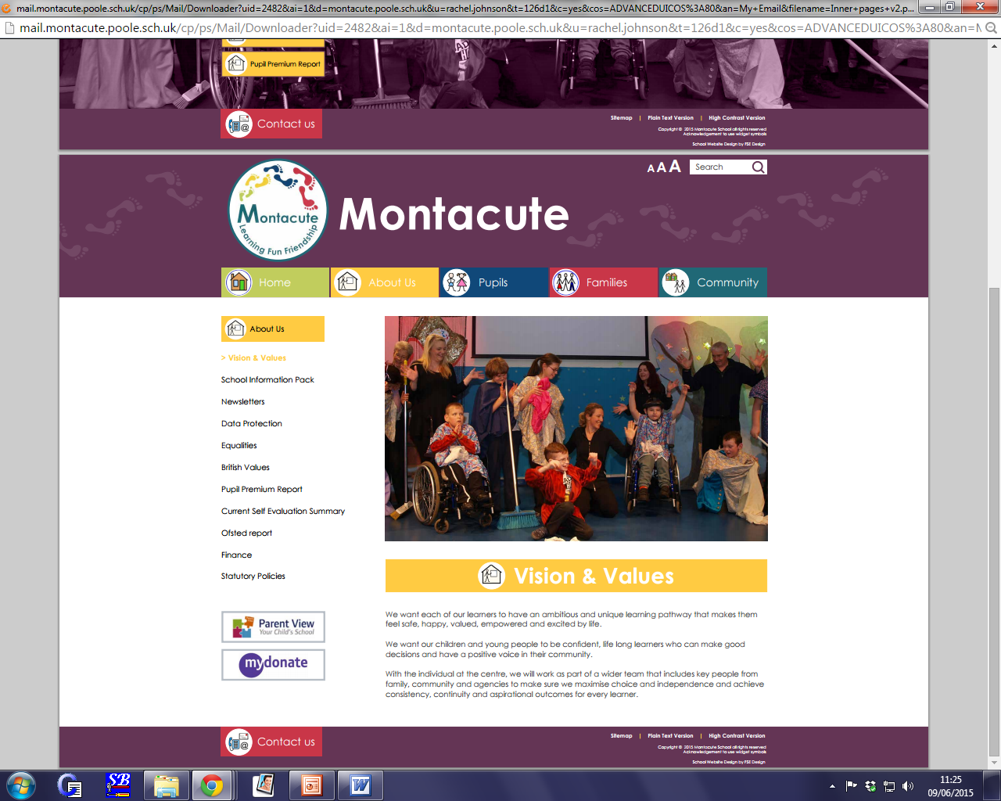
Montacute can take pupils from the age of 2 to the age of 19, or at any points in between.

MONTACUTE VISION AND VALUES
MONTACUTE
VISIAND VALUES

We have recently re-visited our vision. We very much wanted this to be representative of our children’s lived experiences whilst reflecting our ambitions and pride for our school.
This new re-working of the vision will help us to continue to return back to our collective values and aspirations not only for our young people, but for our staff. We will revisit this piece of work periodically to enable reflective practice and ambitions planning for our collective futures.
Vision
Step over the threshold at Montacute school to experience the wonder of a world carefully created to empower it’s very special population.
Every child is unique in their talents and needs. From their smallest whisper to the loudest song every voice is heard.
We are a family, harmonising to create a world full of opportunities, wonder and joy for each of our pupils. We believe in being in tune with the unique characters, voices, learning styles and talent of all our young people and will stand alongside their other supporters to celebrate every achievement they make.
We encourage every one of our treasured pupils and staff members to allow them to shine, sparkle, grow and change ready to take on the world
At the end of the day when their school song has been sung and heard we are confident that the world will be able to listen and hear them too.
It is our school, it is our time, we are Montacute!
Values
Empowerment
On the snowy slopes of Montacute mountain you will be supported to climb as high as you would like. If you feel unsure you will be encouraged to conquer your doubts. Your strengths and interests will be explored and developed in an environment of appreciation. You will grow in confidence. You will understand that you are powerful, that you can climb to the top and feel the sense of exhilaration as you overlook a vast and stunning landscape. You will reflect on your journey and know that you are capable of greatness and you in your turn will support others to become empowered for the future.
Authenticity
Dive beneath the crystal-clear waters of the Montacute Ocean. Leave the air behind and breathe deeply from your own truth. There is another world of colour and beauty. It is deep and clean and real. Home to millions of coloured sea creatures, it is a different world, more magical and even more beautiful than our everyday experience. These animals live a fluid and instinctive life trusting their feelings and living with a clarity of purpose and sense of justice. All are included in the world in a meaningful way where even the smallest of them has a role to play.
Learning

At Montacute we promise to recognise and celebrate every step you take on your journey through our school. We will lend you a hand when you need it and help you carry your bag when it becomes too heavy. We will make sure your eyes are always open to the wonder of the world and surprise you at every turn with our creative and engaging methods of teaching.
At Montacute we understand that some mountains take longer to climb but know we will always be by your side as your biggest supporters, cheering your name and climbing alongside you. When you reach the top of your mountain, we will look back with you and see how far you’ve come and all the beautiful landscapes you have seen.
Respect

At Montacute we welcome you stepping into our world that is designed with all in mind. Walk through our corridors reading as you go, enter a classroom and be transported into a secret garden, climb on board a pirate ship or fly in a hot air balloon around the world. Our language rich classrooms are specifically tailored to make all our pupil’s readers and active learners; you will want to stay even if you are only passing through.
At Montacute our radios are tuned into a huge range of frequencies so no matter how you communicate we will hear you and you will always feel valued and listened too. To us Montacute means family; will help guide and support you, raise you up and hold you closer if you need but above all celebrate all your achievements because we know all the little things add up to fulfilling and joyful life.

JOB DESCRIPTION
JOB DESCRIPTION
RECEPTIONIST / ADMINISTRATIVE ASSISTANT

RECEPTIONIST / ADMINISTRATIVE ASSISTANT
Job title: | Reception / Administrative Assistant | Job Ref: | XS 8.6
Directorate: | Montacute Academy Trust
School: |  | Grade: | Grade 3  APT&C pay range SCP 2-4 (new Apr 2025)
Reports to: | Headteacher/Support Services Team Leader

Main job purpose
To provide reception/telephone services within the school and ensure all visitors and/or telephone callers to the school are received in an efficient and effective manner.
Main point of contact for enquiries from staff, parents and visitors including clerical duties in support of the school office form a significant and flexible element of the job; efficient administrative support, to ensure compliance with the school administrative and reporting requirements, including undertaking manual and computer data entry/extraction and other administrative duties.
Main responsibilities and duties
1. To receive telephone calls and visitors and take appropriate action and to greet visitors and callers to the school and ascertain purpose of their visit, require visitors to sign in and direct them to the appropriate person, in line with safeguarding protocol.
2. To undertake general office duties, including collation/copying reports and documents, organising and maintaining filing systems and assisting in the absence of office colleagues.
3. To complete appropriate data input and paperwork associated with the administrative needs of the school office (e.g. school transport records, pupil database, staff training, lettings etc.).
4. To liaise directly with stakeholders under the supervision of others.
5. To provide administrative support to all areas of the school (e.g. pool users information & timetable, staff listings, training database and pigeonholes).
6. To be responsible for processing incoming and outgoing mail.
7. To undertake computer processing using word, excel, power point, databases and school management information systems (Arbor, Inventry, school online calendar, Dimensions).
8. To liaise with site team to ensure prompt movement of deliveries to the school.
9. To ensure the reception area is tidy and hazard free, all notices are up to date.
10. Promoting and safeguarding the welfare of children and young people in accordance with the school’s safeguarding and child protection policy.
11. To undertake any reasonable tasks required by line managers to a level of responsibility commensurate with this post.
Knowledge & skills
Essential:
Knowledge and understanding of Microsoft office and IT skills.
Keyboard skills, to be able to work accurately, under own initiative for short periods of time and to work in an organised and flexible manner.
Good telephone manner.
Ability to work on own initiative and as part of a team.
Previous experience in similar role preferred
Supervision and management
The postholder will often be required to work without direct supervision. Supervision will be present where necessary.
Problem solving and creativity

At busy times needs to prioritise

Key contacts and relationships

Daily contact by telephone/face to face with Headteacher/Staff/Pupils/Parents and other visitors to the school.
Decision making

There is a need to establish the importance and urgency of contacts made.

Resources

General Office equipment (e.g. laptop, desktop computer, photocopier, scanner, laminator, fax and telephone).

Working Environment

Working in busy Office with frequent use of IT equipment
Occasionally processing heavy loads of incoming/outgoing mail.
The post is subject to constant interruptions.
Disclosure and Barring Service
The nature of the work requires that the post holder has undergone checks by the Disclosure and Barring Service and has enhanced level of Disclosure.
Health and Safety
The post holder must:
- Follow the school’s Health and Safety Policy
- Always ensure confidentiality and always seek to behave within professional boundaries
- Ensure work is conducted within the framework of all local guidelines and policy
Equal Opportunities
The post holder has a responsibility to understand and abide by the obligations laid down in the school’s equal opportunities policy.
HEAD TEACHER: ……………………………….

EMPLOYEE: ………………………………………

DATE: ……………………………………………….

HOW TO APPLY

Download details and application form from our school website https://www.montacute.poole.sch.uk/vacancies-1/

Please send completed applications to Sarah Toop at Montacute School, 3 Canford Heath Road, Poole, Dorset, BH17 9NG
or email: sarah.toop@montacute.poole.sch.uk

Informal visits to the school are warmly encouraged. To arrange a visit please contact the office on tel.no. 01202 693239

We look forward to hearing from you!

