
Headteacher Recruitment Pack



Message from the Chair of Governors | 3
Details of the post | 5
Safeguarding | 8
Mission and values | 9
School information and history | 11
How to apply | 14
Living and working in West Dorset | 15
Job description | Appendix 1
Person specification | Appendix 2
Headteacher Standards | Appendix 3

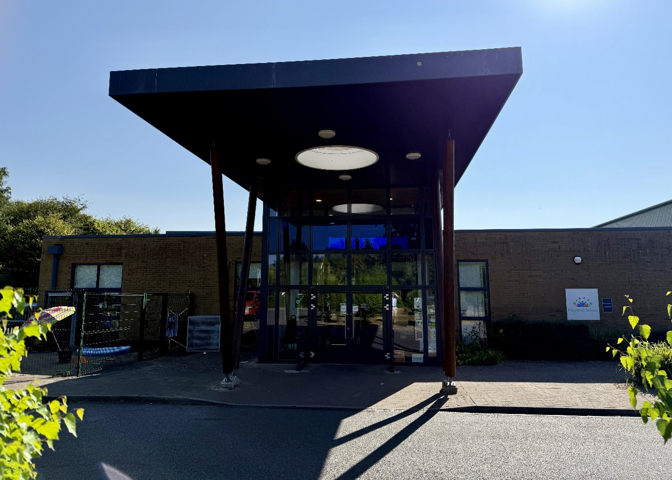

Mountjoy School



Message from the Chair of Governors

Welcome to Mountjoy School and thank you for your interest in applying to become our new Headteacher.

Guided by our core ethos of “making a difference today for tomorrow,” we are immensely proud of the nurturing, ambitious, and inclusive environment we have created here in Beaminster. Mountjoy is a close-knit, vibrant community special school catering for up to 110 learners aged 4 to 19 with complex learning needs, including Severe and Complex Learning Difficulties (SLD/PMLD) and Autistic Spectrum Disorder (ASD). Our dedicated staff team works tirelessly to ensure that the child remains at the absolute center of everything we do, a commitment reflected in our consistent Ofsted rating of 'Good' in all areas.

As a Governing Body, we are deeply committed to your success and well-being. We offer a highly professional, collaborative partnership, a skilled and passionate staff cohort, and a school full of incredible young people who inspire us daily.

We have a purpose-built, single-level school building with a hydro pool, sensory room and soft play area. The school has grown significantly in pupil number in recent years, to meet a growing local need and this has resulted in a number of changes to the school building to meet the challenges that being oversubscribed brings. We now have a significant and transformative 'new build' project on the horizon fully supported by Dorset Council.

Provision is underpinned by a pathways model, an approachwhich ensures that learning is personalised, meaningful and ambitious carefully designed to support pupils’ progress, wellbeing and preparation for adulthood. Where appropriate, pupils are supported to achieve accredited outcomes, alongside the development of independence and life skills.

The school also plays a vital role within the local educational community, providing specialist outreach and guidance to mainstream schools and Inclusion Hubs across Dorset.

We are seeking an experienced and skilled leader who will be proactive in promoting relationships with parents, carers and the community and who will work collaboratively with the staff to ensure our children are safe, happy and well-cared for, and to secure the best possible outcome for their needs and abilities. You will be capable of operating at a strategic level in relation to finance and resources, and account to governors for all school business, including safeguarding and compliance
We have strong relationships with our parents and carers, who are encouraged to visit the school and take part in activities that throughout the year, often organised by the Friends of Mountjoy.

The governors visit the school regularly; each governor is linked to an area of the school’s School Improvement Plan. They maintain excellent relationships with the staff and give strong support to the SLT.

Whether you are an experienced special school leader looking for your next legacy project, or an ambitious senior leader with a deep-rooted passion for specialist SEND provision, we would love to hear from you.


We warmly welcome and encourage informal visits to the school ahead of the formal application window opening on 1st September 2026. To arrange a visit, or to speak to us regarding the registration of your interest, please contact v.reed@mountjoy.dorset.sch.uk or call 01308 861925.

Thank you once again for your interest in Mountjoy School. We look forward to receiving your application and exploring how, together, we can continue making a difference for our learners.

Yours sincerely
Helen Farmer
Chair of Governors

Headteacher – Mountjoy School, Beaminster Dorset

Due to the retirement of our current Headteacher, the Governors of Mountjoy Special School are currently seeking an experienced and dedicated Headteacher to lead our school starting in January 2027. As Headteacher at Mountjoy you will be responsible for the overall leadership, management, and development of the school. You will work closely with staff, students, parents, and governors to ensure high standards of education and wellbeing across the school. This role requires strong leadership skills without adherence to any specific curriculum framework.

WHY THIS OPPORTUNITY MATTERS
The next Headteacher will lead at a time when:
- Demand for SEND provision continues to rise.
- Outcomes for children with complex needs must remain ambitious.
- The SEND and AP Improvement Programme continues to influence national policy.
- Schools face increasing workforce challenges.
- Partnership working is increasingly important.

The Governors are seeking a leader capable of navigating these challenges whilst maintaining the school's values and high standards.

Mountjoy School is a vibrant and unique Special School, supporting 110 pupils aged 4 to 19 with a range of learning differences.

The school is arranged into 12 classes, from Early Years to Post 16. Close to the Dorset, Somerset and Devon boarders, and within the beautiful Jurassic Coast area, we make the most of our location, taking our learning out of the classroom at every opportunity. We support all our pupils to achieve their full potential. We are rated Good by Ofsted, have achieved Rights Respecting Award at Gold Level, A MOVE School at Silver Level, an Eco-Schools Green Flag and are an Apple Regional Training Centre. We were delighted to receive a national award in May this year for our work on inclusion, from the Council for Disabled Children. All of our work is underpinned by Therapeutic Thinking, a theory driven, psychologically informed, whole-school approach focuses on how children and young people are supported.

Future Horizons: Shaping Our Next Chapter
At Mountjoy School, we never stand still. While our current state-of-the-art specialist facilities provide a wonderful foundation for our learners, we are embarking on a transformative new phase in our school’s history.
With an exciting ‘new build’ project on the horizon, our incoming Headteacher will have a rare opportunity to shape the physical and educational landscape of Mountjoy.

The Project & Strategic Opportunity
This upcoming capital development project is designed to expand our facilities, modernise our learning environments, and ensure Mountjoy remains at the absolute forefront of specialist SEND provision.
For an ambitious, forward-thinking leader, this project offers a unique platform to:

- Influence Design and Philosophy: Work alongside the Governing Body, local authority to ensure the new spaces directly reflect our child-centred ethos and meet the evolving needs of our learners.
- Lead Innovation: Integrate cutting-edge assistive technologies, modern sensory environments, and specialized vocational spaces into the new build.
- Manage Change: Guide our dedicated staff team, pupils, and families through an exciting period of transition, ensuring continuity of high-quality education and care throughout.
- Build a Lasting Legacy: Deliver a physical and educational environment that will "make a difference today for tomorrow" for generations of young people to come.
Birds eye view of proposed development site

What We Need in Our Next Leader
Capital projects of this scale require a leader with specific strategic capabilities. In relation to the new build, our ideal candidate will possess:

- Strategic Vision: The ability to see beyond the brick-and-mortar to design spaces that enhance independent living skills, emotional regulation, and communication for all learners.
- Exceptional Communication: The warmth and clarity needed to keep our close-knit community informed, engaged, and inspired by the journey ahead.
- Significant leadership experience of working in a special school setting
- A passion for creating an inclusive educational environment where every student can thrive
- Integrity, fairness, and transparency in all dealings with staff, students, parents, and stakeholders
- A collaborative approach that values teamwork among staff members and encourages professional development
- Resilience under pressure combined with a positive outlook on challenges
- Dedication to fostering respect, kindness, responsibility, and ambition within the school community

What We Can Offer You
At Mountjoy School, we believe that exceptional leadership deserves exceptional support. As our Headteacher, you will be joining a school that prioritises professional fulfilment, collaborative governance, and personal well-being, all set within one of the most beautiful parts of the country.
We offer our next leader:

- A Legacy-Building Project: The unique, career-defining opportunity to spearhead our upcoming 'new build' project and directly shape the future of special education in West Dorset.
- Incredible Learners: A vibrant, proud, and affectionate student body of up to 110 pupils who inspire us every day and sit at the absolute centre of everything we do.
- A Highly Skilled, Dedicated Team: A staff cohort of deeply committed, specialist professionals who are passionate about absolute inclusion and child-centred education.
- A Fully Supportive Governing Body: An active, engaged, and expert board of governors who provide robust strategic partnership, champion your well-being, and genuinely invest in your success.
- State-of-the-Art Specialist Facilities: Immediate access to top-tier resources, including our sensory studio, and hydrotherapy pool.
- Competitive Financial Package: A rewarding salary on the Leadership Scale L21 – L35 (£87,664 – £123,528), reflecting the scale and strategic importance of this Group 6 role.
- An Unmatched Lifestyle: A rare quality of life in Beaminster, surrounded by the stunning Dorset National Landscape and situated just minutes from the iconic Jurassic Coast.

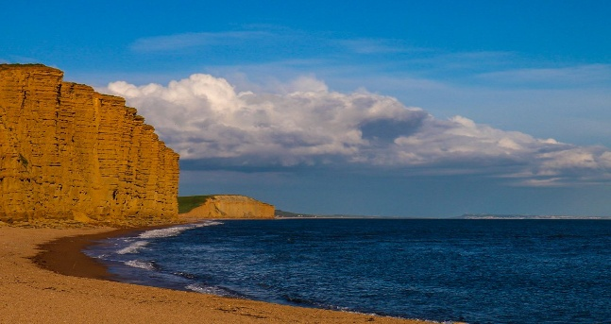

Salary: L21 - L35
Salary Details: Leadership Scale Group 6
Organisation: Dorset Council
Location: Tunnel Road, Beaminster
Dorset DT8 3HB
Job Term: Permanent
Contact email: v.reed@mountjoy.dorset.sch.uk
Contact telephone: 01308 861925
School website: www.mountjoy.dorset.sch.uk
School visits: Tuesday 8th Sept 10-11.30am
Thursday 10th Sept 1 to 2.30pm
Application closing date: 14th September 2026 (11.59pm)
Shortlisting date: 15th September 2026
Interview dates Monday 21st and Tuesday 22nd September 2026

To arrange a visit to the school, please contact Vicky Reed PA to the Head on v.reed@mountjoy.dorset.sch.uk.

N.B. The governors are open to exploring alternative headship models.

For school policies, Ofsted report and a wealth of additional information please visit the school website.

Diversity Statement We welcome applications from all sections of the community, regardless of gender, race, religion, disability, sexual orientation, age or any protected characteristics in the Equality Act 2010.

Safeguarding Statement:
In line with Keeping Children Safe in Education 2025, as a part of our recruitment process, we will carry out an online search on shortlisted candidates to identify any comment, image or other content that could cause reputational damage to the school and/or give rise to a safeguarding concern. If we discover anything during our searches, this will be passed on to the Chair of the panel and discussed during interview.



We are deeply committed to safeguarding and promoting the welfare of children and expect all staff, governors and volunteers to share this commitment. All necessary safeguarding checks will be undertaken which must have satisfactory outcomes, otherwise the conditional job offer may be withdrawn. Details of the checks that will be undertaken can be found within the Keeping Children Safe in Education, 2025 document.

This role has been assessed as working in regulated activity and is subject to an Enhanced DBS plus children and adult’s Barred List Check

Any offer of a position will be subject to satisfactory references and DBS check.

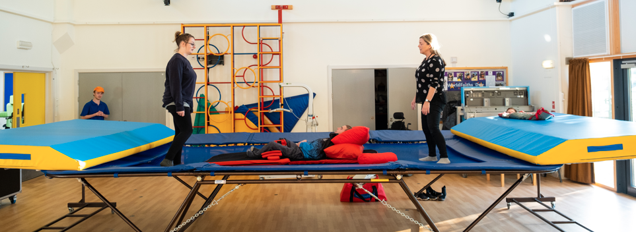

Our Vision:
We want to prepare our children and young people for adult life so they have options and aspirations. They need to be confident and happy so they can thrive in the real world.
MAKING A DIFFERENCE TODAY, FOR TOMORROW

Our mission:
- Every day we concentrate on teaching knowledge and skills so that our pupils can deepen understanding of the wider world, cultivate personal attributes like emotional awareness, empathy and self-regulation and develop the learning virtues of curiosity, creativity and collaboration.
- Every person in our school community uses good thinking and learning to raise expectations for all. Teachers research their own professional practice to make it effective, engaging and fun, and share knowledge which each other modelling collaboration to their learners.
- Learning happens everywhere in school and outdoors; we strive to engage the wider community including parents and employers so that learning continues beyond school hours.

Our values:

Passion – use time well and enjoy it; life is precious

Respect – treat others properly; we are all equal, we are stronger together

Optimism – be hopeful; imagine the best future and make it happen

Understanding – walk in someone else’s footsteps; help each other

Determination – strive to overcome obstacles; we can make it work





Ofsted November 2022 report states

‘Adults in the school are rightly proud of the nurture and care they provide. This is seen from the moment pupils arrive at school. Pupils are greeted with a smile and a warm welcome.

‘Excellent, supportive environment’ and ‘Marvellously gentle, kind and nurturing’ were typical comments made by parents.’

‘The child is at the centre of everything the school does.’

‘Leaders provide regular support and guidance. Staff appreciate
this supportive approach; it gives them the knowledge and confidence to teach early reading with skill.’

‘Adults love working at Mountjoy. They appreciate the training which develops their own knowledge and skills. They appreciate the focus leaders place on their mental health and well-being.’

School Information and History

Mountjoy School moved to its current site in Beaminster, West Dorset in November 2012. We are a local authority maintained special school. Currently we are excited to be looking at a potential new build to give us greater facilities adjacent to the present school in order to develop our outdoor learning and to improve our facilities for our Secondary cohort.


We are close to the world-famous Jurassic Coast, in a beautiful part of the country. The school makes use of our local area to run beach and forest school sessions regularly, and organises many off-site visits and learning opportunities for our pupils, to enable them to learn beyond the classroom environment.

Our school houses a hydrotherapy pool, which is used on a daily basis, for hydrotherapy, swimming and curriculum lessons.


We have a strong therapeutic offer.

In addition to having a number of Therapeutic Thinking Tutors in school, we benefit from Local Authority Educational Psychology and CAMHS ID support.

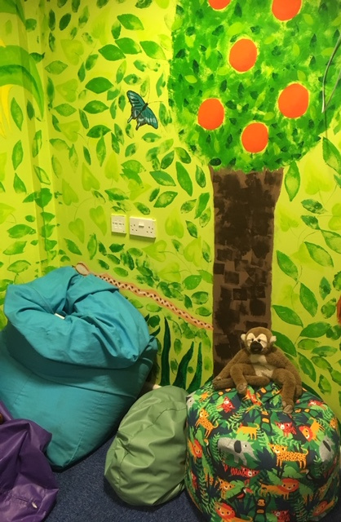
Our Emotional Support Time (EST) room is utilised by our School Counsellor, our Music Therapist and our Emotional Support Team who receive regular training and supervision by an Educational Psychologist.

We have a soft play room and sensory room. Our Occupational Therapist is integral to school life, as we have many children who need support with sensory processing. Our OT also trains in Developmental Play which is incorporated into our Mountjoy Sensory Curriculum.

We employ a Speech and Language Therapist for two days per week and we have expertise in AAC as many pupils use it as their primary mode of communication.

Learning outdoors is very important to our pupils and we have a range of trips and activities all through the year.

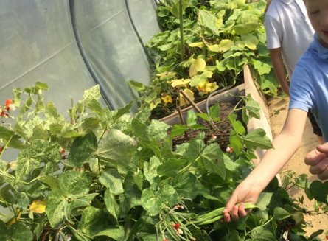
Our outdoor area is home to our polytunnel, which the Post 16 pupils manage as part of their Enterprise efforts, producing fresh vegetables which are used by our school chef and sold. We also have a forest school and beach school training outdoor classroom on our field, to prepare our learners for being off-site. Our Sensory Garden is enclosed and enables pupils to regulate and learn in a safe and secure area.



Our school currently has 112 pupils on roll, aged from 4 to 19 years, and with a range of complex ASC and SLD needs. Pupils attend from Dorset, Somerset and Devon. The school has a well subscribed Post 16 class, although the majority of our students transfer to colleges and other settings after Year 11. Our Post 16 Curriculum prepares our students for life after school, with lots of opportunities to explore the community and develop growing independence.


The staff are a committed body of professionals who are resilient and rise to the challenges of education. Many of the staff have been with the school for some years, and we also have parents of pupils at the school. There are good CDP opportunities for staff, and the SLT are supportive of staff who wish to take up CPD opportunities.
We offer training and outreach support to other schools across Dorset as a member of TADSS (Teaching Alliance of Dorset Special Schools).

The school employs two Family Liaison Officers, and a SENCo, who all support our families well. In return, we have amazing support from our families and very good uptake at the many events we run.

The school values the relationship with parents and carers and recognises their voice when making decisions around the needs of their child. We aspire to good communications at all times with our pupils and students’ parents and carers and our partners. Our next Headteacher will share this passion and, through the senior team, build a programme of accessible and meaningful engagement activities throughout the year for parents and children and the school.
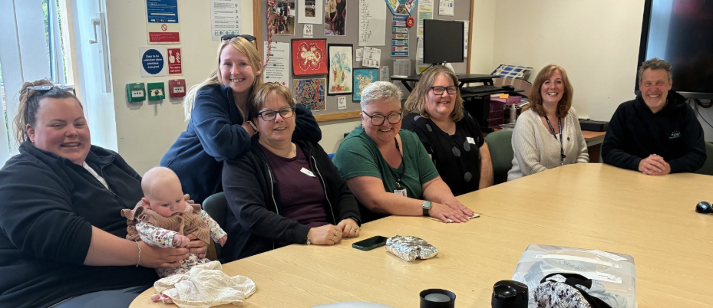

Curriculum
Mountjoy School is made up of incredible children, each with their own unique personalities and abilities. We believe that we need a diverse and flexible curriculum to meet the range of learning needs of our students. As such the school's curriculum employs informal, semi-formal and formal curriculum approaches.
- Early Years Foundation Stage Curriculum
- Mountjoy’s Multi-Sensory Curriculum or MSC (some pupils have a blended offer)
- Adapted National Curriculum (most learners are working at least four years behind age-related expectations)
- ASDAN - Life Skills Challenges
- Functional Skills Courses
- Post 16 Life and Independence


Pupil Progress
Our pupil progress is evidenced through the use of highly personalised MAPS (My Aspirational Progress). The MAPs cover a range of areas, either linked to the NC, MSC, EYFS or Post 16, dependent on age and stage. Parents, teachers, SLT, support staff, pupils and therapists all input to the MAPs.

Please see our current SIP and SEF on our website for information about our priorities.

How to apply

You will be directed through the portal pages to submit your application. Please check that you have completed all required information.

Visits to the school are welcome and actively encouraged. If you are interested in applying, we would be delighted for you to visit our school in advance of your application.
Dates available are: Tuesday 8th Sept 10-11.30am Thursday 10th Sept 1 to 2.30pm

Completing your application

Please read this application pack carefully. We ask that you ensure the items set out in the Person Specification are addressed within your application, providing evidence from your existing or previous positions, paying particular attention to the key focus areas and to the impact of your work.
The job description, person specification and headteacher standards are there to support your application alongside visits to the school and accessing the website Completed applications must be received by 12.00am on 14th September 2026

Selection procedure

Those shortlisted for interview will be notified initially by phone on 15th September with a follow up email with details of the two days. If you are not contacted this means that you have been unsuccessful, however we want to thank you for your interest in Mountjoy School and wish you well for the future.

References will be sought for shortlisted candidates prior to the interview date.
Further details will be sent to those candidates called for interview.

The selection process will take place at the school on 21st and 22nd September the process will be undertaken by a panel of governors, assisted by the school’s Education Challenge Lead and members of the school community.

The governors look forward to working in partnership with the successful applicant to continue the journey of development and improvement of our school.

Contact details:

MOUNTJOY SCHOOL, TUNNEL ROAD, BEAMINSTER,
DORSET DT8 3HB

T: 01308 861155
website: www.mountjoy.dorset.sch.uk
email: office@mountjoy.dorset.sch.uk

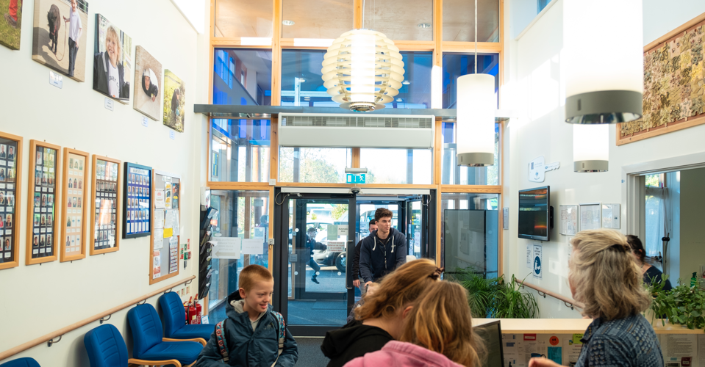

Living and Working in West Dorset: A Rare Quality of Life
Mountjoy School is located in the historic market town of Beaminster, nestled within the Dorset National Landscape (formerly Area of Outstanding Natural Beauty) and just a short drive from the spectacular Jurassic Coast, a UNESCO World Heritage Site.
Choosing to lead Mountjoy School offers not only an exceptional professional opportunity but also an enviable lifestyle change. West Dorset seamlessly blends a vibrant community spirit, rich cultural heritage, and unmatched natural beauty.

Local Life and Community
- Bustling Market Towns: Beaminster offers a historic square filled with independent shops, artisan cafes, and restaurants. Nearby Bridport is renowned for its thriving arts scene, twice-weekly street markets, and the vibrant vintage quarter.
- The Jurassic Coast: Located less than twenty minutes away from coastal gems like West Bay (famous for its iconic golden cliffs) and Lyme Regis, providing world-class walking paths, fossil hunting, and water sports right on your doorstep.
- Food and Culture: The region is a celebrated hub for local produce, featuring acclaimed farm shops, traditional country pubs, and independent festivals celebrating food, literature, and music.
- Outstanding Education: Alongside the specialized provision at Mountjoy, West Dorset boasts excellent mainstream primary and secondary schools, making it a wonderful environment for families.
Transport and Connectivity
While West Dorset offers a peaceful, rural setting, it remains well-connected to major towns, cities, and transport corridors across the South West and London.
🚆 By Rail
Regular, direct rail services to London Waterloo run from nearby stations:
- Crewkerne Station (approx. 15-minute drive from Beaminster) connects directly to London Waterloo in under 2.5 hours.
- Dorchester Stations (approx. 25-minute drive) provide alternative direct routes to London Waterloo and Bristol Temple Meads.
🚗 By Road
- The A3066 passes directly through Beaminster, linking it south to the A35 (coastal trunk road connecting Honiton, Bridport, Dorchester, and Bournemouth) and north to the A303 corridor for fast access to London and the Home Counties.
- Approximate drive times: Dorchester (30 mins), Taunton/M5 (45 mins), Exeter (1 hour), Bournemouth (1 hour 15 mins).
✈️ By Air
- Exeter Airport (approx. 50-minute drive) and Bristol Airport (approx. 1 hour 20-minute drive) provide comprehensive domestic and international flight options.
Housing and Relocation Support
Whether you are looking for a characterful thatched cottage in a quiet Dorset valley, a historic townhouse, or a modern family home, West Dorset offers a diverse and attractive property market.
If you live outside of the South West, a bespoke relocation package to assist with transition expenses may be negotiated for the successful candidate.

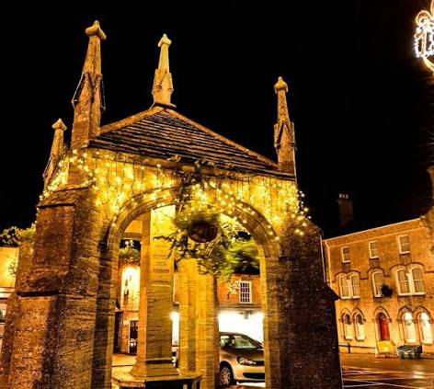

Beaminster Town, Dorset

