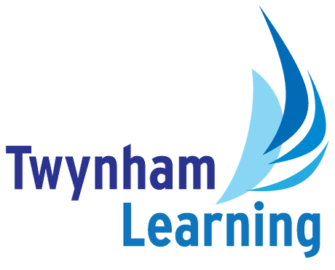
Job Description:
Core Services Support Assistant

Post Details
School/setting: | Twynham Learning Core Services
Post type: | Support Staff
Grade/Pay Level: | Grade 6
Responsible to: | Director of Inclusion & Wellbeing

Main Purpose
To provide efficient and effective and comprehensive administrative and general support to the Twynham Learning multi-academy trust’s ‘head office’ team (known internally as ‘Core Services’). Supporting the smooth co-ordination of operations across multiple schools, including Estates, Finance, HR, Governance, and Data Management functions. Maintaining high standards of accuracy, confidentiality, and customer service. Providing a professional, responsive, and high-quality service to staff, parents, and external partners. The role requires effective co-ordination across multiple schools within the Trust, ensuring clear communication and the timely sharing of information between sites. The post holder will support centralised processes and contribute to their consistent implementation, as well as assist in the organisation and delivery of cross-school events, training sessions, and collaborative activities.

Duties and Responsibilities
General Administration
- Managing incoming communications such as emails, telephone calls, and post, responding appropriately or escalating/redirecting as necessary.
- Preparing agendas, taking accurate minutes and following up on actions arising from meetings.
- Drafting correspondence, reports and presentations.
- Printing, photocopying, scanning, enveloping and shredding documents as necessary.
- Updating the trust’s website as required (including posting job vacancies from time to time).
Data & Records Management
- Maintaining and updating databases, including the trust’s management information system, ensuring that records are accurate and up to date.
- Collating and preparing data reports for Executive teams, as well as supporting audit processes and wider compliance checks.
- Maintaining organisation charts showing the members of the Core Services and Executive Leadership teams.
Event & Diary Management
- Managing calendars for senior trust leaders, and overseeing the trust-wide calendar to ensure effective scheduling and coordination.
- Organise meetings, conferences, and training sessions, taking responsibility for all logistical arrangements, including booking venues, travel, and accommodation where required.
Governance-Specific Support
- Administer the trust's annual declarations of business interests and related party transactions process for Members, Trustees, Ambassadors, senior leaders and designated staff.
- Maintain records of business interests, related party transactions and governance declarations, ensuring completeness, accuracy and timely updates. Undertake initial related party checks and maintain associated records and compliance trackers.
- Coordinate periodic declaration reviews and issue reminders to ensure compliance with trust governance requirements.
- Maintain governance databases and records, including statutory governance records relating to Members, Trustees and School Ambassadors.
- Provide administrative support for governance meetings, panels and hearings. Support the administration of suspension, exclusion, complaints and other governance panels. Provide administrative support for governance-related training events and development activities.
- Maintain governance calendars and coordinate annual work programmes.
- Support governance arrangements for trust partnerships and associated boards where required.
- Assist with governance recruitment processes and onboarding administration. Coordinate induction arrangements and maintain governance training records.
- Assist with the publication and maintenance of governance information on trust and school websites to ensure compliance with statutory requirements.
- Support policy management processes, including version control, consultation administration, publication and review scheduling.
- Support the Governance Manager with compliance monitoring, reporting and audit preparation.
General office environment support
- Support for visitors – arranging parking, greeting them, escorting from Reception to their destination, providing refreshments.
- Arranging catering for meetings/events.
- General office support tasks, such as watering plants, emptying the dishwasher, setting up for meetings/clearing up afterwards and replenishing supplies.

Safeguarding Duties and Responsibilities
- Promoting and safeguarding the welfare of children and young people in accordance with the school’s Safeguarding and Child Protection policies.

Other Duties
- Ensure compliance with GDPR and data protection regulations, working in liaison with relevant colleagues where appropriate.
- All Twynham Learning staff may periodically be expected to carry out tasks and duties within their area of competence that are not listed herein, as directed, to meet the needs of the Trust. The particular duties and responsibilities may vary from time to time.

Twynham Learning Attributes for all Staff
- Ambition for excellence  - Professionalism  - Humility  - Championing change | - Inclusiveness  - Positivity  - Community-mindedness  - Being collaborative

Qualifications, Knowledge, Skills and Attributes Required
Essential:
- Some experience of working at a school or trust in an administrative capacity
- 5 GCSEs including English and Maths, grade A*-C or equivalent
- Experience of producing meeting minutes and documents of high quality
- Strong IT skills, especially Sharepoint, Microsoft Outlook, Word, Excel and Powerpoint. Ability to process documentation (e.g. letters, mail merge, minutes, spreadsheets) and use databases, management information systems and input/retrieve data as appropriate
- Highly organised, with the ability to work independently, be proactive, prioritise own workload and work under pressure
- To be able to work to tight deadlines and prioritise tasks appropriately
- Meticulous eye for detail
- Friendly, helpful and flexible approach with excellent communication skills and customer service
- Well-developed interpersonal skills with the ability to communicate both verbally and in writing demonstrating tact and professionalism in order to develop good relationships both within and outside the organisation
- Good sense of humour
- Ability to be discrete and maintain confidentiality
- Ability to work flexibly on occasions to support events outside of normal working hours

Desirable:
- Further qualification or training in Business Administration or Communications
- Knowledge of website maintenance
- Experience as a Personal Assistant
- Experience of office management

Notes
- This job description may be amended at any time in consultation with the postholder.

Glossary
- Explanations of any abbreviations or jargon contained in this job description can be found in our Twynham Learning Glossary.

