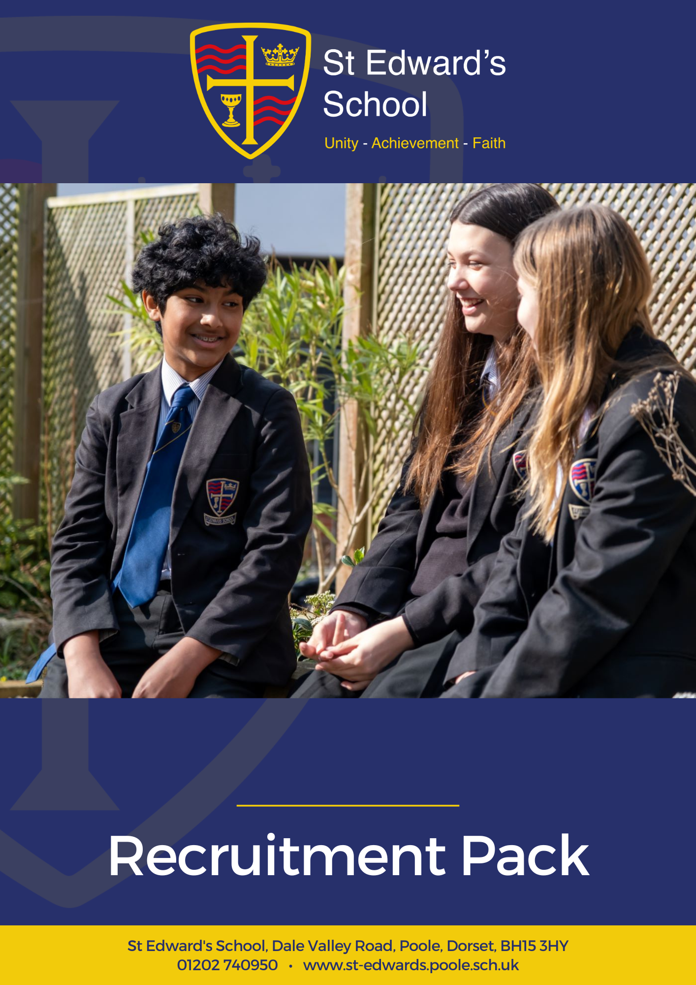

HIGHER LEVEL TEACHING ASSISTANT
SEND PASTORAL

HIGHER LEVEL TEACHING ASSISTANT

SEND PASTORAL

Grade F SCP 12 or 17 dependent on experience
£28,598 - £31,022 pro-rata (Pay award pending)
Actual Salary £21,510 - £23,333

St Edward’s School is a high-performing school with an amazing SEND team. Our school is heavily oversubscribed and enjoys an excellent reputation for combining high expectations of all, with warm relational approaches to learning.

We are looking for an HLTA to join our strong and supportive team. As an HLTA you will become part of a caring organisation deeply focused on securing outstanding futures for young people.

You will need to be experienced, enthusiastic, proactive, and familiar with the secondary school context, have strong behaviour management skills and have good administrative and organisational skills. Experience in delivering emotional literacy, SEMH or Autism support is essential.
What are we looking for in you? Applicants will need to be experienced, enthusiastic, proactive, and familiar with the secondary school context. You will have a sincere commitment to our ethos and vision as a school, and our drive for continuous improvement. In return we offer a happy working environment, fantastic students, great facilities, tailored CPD and a highly motivated staff community.

The post is permanent, 32.5 hrs per week, term time only including INSET days working between the hours of 8.25am and 3.30pm Monday to Friday.

Please visit our website at https://st-edwards.poole.sch.uk/ for further information about our unique school.

St Edward’s School is committed to safeguarding & promoting the welfare of children & young people. All appointments made are subject to an enhanced DBS check. Online searches may be carried out as part of due diligence checks.

Closing date: Sunday 20 September 2026
Interview Date: TBC

Our Mission Statement
MAY WE BE ONE
In Purpose
Educating for life in all its fullness
In Faith
Encountering God who lives among us, calling us to unity
In Dignity
Nurturing confidence and maturity

About Us
St Edward’s School opened in 1963 as Roman Catholic School serving the parishes of Poole. It took its name from the local Saint, martyred at Corfe Castle. Although little is known of Edward, as a teenage king with a strong Christian faith and a commitment to protecting the poor he provides an excellent role model for our young people. His story is told through our school badge with the crown of a king, the cross of Christ, a cup to symbolise his murder by poisoning and the blood of a martyr. The crown and cup also remind us of the Kingdom of God, and the “one cup in which we all share”. (1Cor 10:16)
For many years, the school welcomed not only Roman Catholic families, but other Christians who were keen for their children to be educated in a faith context. In the early 1990’s the school’s second headteacher, Alan Murphy decided to formalise this arrangement and entered into talks with the Roman Catholic Church and the Church of England about St Edward’s becoming a joint church school. A new covenant, setting out the values and principles behind the commitment was signed by the Bishops of Plymouth and Salisbury in 1993.
From then on, the school has continued to grow in success and popularity. The vision of the school is to provide an excellent education, in a comprehensive and co-educational context that develops the character of young people through the St Edward’s Virtues, while safeguarding their experience of childhood.

Letter from the Headteacher
Thank you for your interest in joining St Edward’s School. I am delighted that you are considering becoming part of our vibrant and caring community.
At St Edward’s, we are committed to preparing young people to live life to the full. We believe that this preparation is best facilitated within a supportive environment that nurtures spiritual and moral development alongside academic excellence. As a joint Roman Catholic and Church of England Voluntary Aided School, Christian values are at the heart of everything we do, guiding our mission to help students become beacons of light to future generations.
Our school is a truly comprehensive and inclusive community, welcoming over 1000 students aged 11 to 18 from all faiths and none. We are proud to be heavily oversubscribed and recognised for our distinctive ethos and high standards. Ofsted, in their most recent inspection in 2022, celebrated our positive learning culture and respectful, kind, and polite students. Our curriculum was praised for being ambitious and challenging, preparing students strongly for future success. In 2023, our Church School Inspection rated us “Outstanding” in all areas.
We have the highest expectations of our students, who leave us ready to attend some of the leading universities, pursue exciting careers, or take empowered next steps in their learning journey. We aim to nurture respectful, resilient, and curious lifelong learners—confident young adults who can connect with others, overcome barriers, and believe in their own limitless potential.

Our staff are central to our success. We value every colleague and the unique contribution they make, regardless of their role. Staff at St Edward’s are encouraged to be creative and to grow professionally in ways that inspire them. We invest heavily in professional development so that all staff continue to find joy and fulfilment in their work. Our ambition is for your career to be rewarding and satisfying, and for you to be happy in your role.
St Edward’s is a happy place to learn and work. Every member of our community plays a vital role in maintaining our ethos and values. We do not make excuses for poor behaviour, but instead foster a culture of compassion, growth, and high expectations.
I am proud of our wonderful students, our dedicated staff, and our supportive governors, parents, and carers. I hope that your experience of us will lead you to believe that St Edward’s is the right home for you. We would be glad to speak with you or welcome you for a visit if you’d like to find out more
Mr Chris Barnett
Headteacher
Working at St Edward’s
St Edward’s is a popular place to work with low staff turnover and high levels of staff wellbeing and satisfaction. Our mission statement of ‘may we be one’ goes to the heart of what we do and how we do it and staff feel positive about the school and their role within it.
We have invested in the Employee Assistance Programme, which gives all staff access to confidential advice and support. The 24-hour support covers a wide range of areas, both work related and more general, including counselling, specialist information and financial and legal matters.
“EAP will always be there to support teachers and education staff no matter what you’re going through, big or small, we’re here for you. Day or night you can call to speak to someone without judgement who can help you find solutions to move past a difficult situation in your life.”
 | I enjoy my work
    If work gets difficult, I know how to get support | The school has supported my wellbeing | I would recommend the school as a place of work
98% | 97% | 100%  98%
Staff Wellbeing Survey – Spring 2026

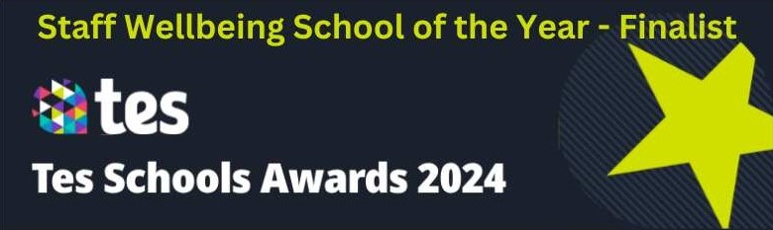
Support Staff Testimonials
“St Edward's has evolved over the years and continues to flourish. I’m proud to be part of a successful school which feels more like a community than a workplace, which is quite unique. St Edward's is a caring and considerate place and I feel valued in my role.”  Jan Forkasiewicz, Receptionist  11 years at St Edward’s | 
 | “St Edward's feels more like a family than a workplace. We thrive on Christian beliefs and values. We look after each other's wellbeing and support each other every day. I’ve never seen so many smiles on children's faces in all the schools I've worked in; they genuinely seem happy and so do the staff. The family orientated atmosphere enables our students to achieve the best outcomes in their subjects and after school activities. We are strong together.”  Dorota Hall, Senior HLTA  7 years at St Edward’s
“St Edward’s is unlike anywhere I’ve worked before. The ethos and vision of the leadership team is crystal clear and runs through all that we do. Everyone involved with the school is committed to and working towards the common goal of providing the best possible environment to allow young people to thrive.”  Felix Carey, Marketing Officer  3 years at St Edward’s | 
Staff Recruitment Information
APPLYING
Please read the Job Description and Person Specification before fully completing the application form. Where there are any gaps in your employment, please state the reasons why e.g. gap year, career break, unemployed etc. and give exact dates.

SUPPORTING INFORMATION
This section is very important as it gives you the opportunity to show us why you are applying and why you would be the best person for the job advertised. Please use the job description and person specification as a guide and give specific examples where possible, to demonstrate how you match the requirements of the post.

INTERVIEW AND SELECTION PROCESS
Those candidates who meet the requirements for the post will be shortlisted and invited to interview and details of the interview programme will be confirmed in writing. As part of the selection process, as well as assessing your skills and knowledge against the requirements of the role, specific questions will be asked to assess your suitability to work with children.

Under the Disability Discrimination Act 1995 and 2005, we are legally required to consider making reasonable adjustments to ensure that disabled people are not disadvantaged in the recruitment and selection process. We are therefore committed to meeting, wherever possible, any needs you specify on the application form. Please contact us if you need to discuss this in any detail.

We will consider any reasonable adjustments under the terms of the Disability Discrimination Act to enable an applicant with a disability (as defined under the act) to meet the requirements of the post.

Safeguarding
St Edward’s is committed to safeguarding and promoting the welfare of children and young people and expects all staff and volunteers to share this commitment.

If you do not hear from us by the interview date specified in the advert, please assume that you have not been shortlisted on this occasion.

PRE-EMPLOYMENT CHECKS

References
If you are shortlisted, we will normally take up references before the interview date. One of your referees must be your current or most recent employer. All offers of a post are made subject to receipt of satisfactory references without which we cannot confirm any offer of an appointment. Copies of references or references that are addressed “to whom it may concern” will not be accepted. On receipt of references, your referees may be contacted to verify any discrepancies, anomalies, or relevant issues as part of the recruitment verification process.

Disclosure & Barring Service Check (DBS)
Employment is subject to an enhanced DBS check. Checks will also be made against the Protection of Children List (PoCAL) and the Department of Education and Employment List 99. All such checks must be satisfactory before we confirm any offer of an appointment. Teachers are also checked against the Prohibition from Teaching check.

Under the Rehabilitation of Offenders Act 1974 (Exemption Amendment) Order 1986, there are a number of jobs where we must take account of convictions, even though they are ‘spent’. All posts at St Edward’s School are regarded as such. However, spent and/or unspent convictions may not necessarily make you unsuitable for appointment.

The amendments to the Exceptions Order 1975 (2013 & 2020) provide that certain spent convictions and cautions are ‘protected ‘and are not subject to disclosure to employers and cannot be taken into account.

Validation of Qualifications
All short-listed candidates will be asked to bring original certificates of relevant qualifications to interview. These will be photocopied and kept on file and may be confirmed as genuine with the relevant awarding bodies.

Right to Work in the United Kingdom
Under the Asylum and Immigration Act 1996, it is a criminal offence to employ anyone who is not entitled to live or work in the United Kingdom. Proof of this will be required at interview stage, where you will be asked to provide some original documentation to confirm that you are eligible to work within the UK. Photographic proof of identity will also be required.

Medical Assessment
A satisfactory medical assessment will be required before we confirm any offer of an appointment.

Child Protection
We are committed to safeguarding and promoting the welfare of children and young people and expect all staff and volunteers to share this commitment. We have a designated senior member of the leadership who is responsible for referring and monitoring any suspected cases of abuse. All members of staff will receive training in line with our child protection policy.

Code of Conduct
We believe that it is essential for standard of conduct at work to be maintained to ensure delivery of quality services and also to protect the wellbeing of all its employees and students.

St Edward’s School governors and headteacher regard everyone working within St Edward’s as a role mode to our students. As such employees should conduct themselves with integrity, impartiality, and honesty. Furthermore, everyone within St Edward’s school has an absolute duty to promote and safeguard the welfare of children.
JOB DESCRIPTION

Job Title: | Higher Level Teaching Assistant – SEND Pastoral
School: | St Edward’s School
Salary Grade: | Grade F SCP 12 - 17  £28,598 - £31,022 pro rata  Actual Salary £21,510 - £23,333
Terms | 32.5 hrs per week between 8.25am and 3.30pm  including INSET days
Responsible to: | SENCO

Main Job Purpose
All aspects of the job description are to be carried out within a system of supervision by qualified SENCo/teacher:
- To support students with neuro diverse conditions and social, emotional and mental health difficulties.
- To complement teachers’ delivery of the National Curriculum.
- To oversee and co-ordinate ELSA interventions and Social Skills interventions.
- To provide support for students, teachers and the school in order to raise standards of literacy/numeracy for all students (e.g. SEND, EAL, GT, Pupil Premium, all underachieving groups), by utilising advanced levels of knowledge and skills when assisting with planning, monitoring, assessing and managing classes. To encourage students to become independent learners, to provide support for their welfare, and to support the inclusion of students in all aspects of school life.
- To provide support to the wider school as Autism Champion advocating for students with Autism Spectrum Conditions

Main Responsibilities and Duties
The following is not a comprehensive definition of the post. Post holders are expected to undertake work that comes within the remit of the posts primary objective. The job description will be kept under review and may be changed at any time following consultation with the post holder.

Higher Level Teaching Assistants (HLTA’s) are members of a multi-disciplinary team working under the supervision and general direction of the SENCo.

They will:
- In accordance with the arrangements made by the Head teacher, progress students’ learning in a range of classroom settings, including working with individuals, small groups and whole classes where the assigned teacher is not present, in line with the regulations and guidance in section 133 of the Education Act 2002.
- Work within a system of supervision teaching whole classes.
- Design learning for small groups. Plan for, teach and assess small withdrawal groups of students/individuals in literacy, numeracy, and support the learning of students with SEMH and/or Autism by providing targeted support.
- To assist teachers in making smooth transitions for students between educational phases.
- Provide detailed verbal and written feedback on student progress and responses to
learning activities and student behaviour as required.
- Plan and prepare lessons with teachers, participating in all stages of the planning cycle, including lesson planning, evaluating, and adjusting lessons/work plans.
- Develop and prepare resources for learning activities in accordance with lesson plans and in response to student need.
- Contribute to the planning of opportunities for students to learn in out-of-school contexts in line with schools’ policies and procedures.
- To advance students’ learning in a range of classroom settings, including working with individuals, small groups, and whole classes within the agreed system of supervision.
- Assess student progress against bench line data.

Support of the student:
- Celebrate diversity and inclusion, challenge discrimination and ensure that all students have equal access to opportunities to learn and develop.
- Promote and support the inclusion of all students, including those with specific needs, both in learning activities and within the classroom.
- Use relational behaviour management strategies, in line with the school’s policy and procedures, to contribute to a purposeful learning environment and encourage students to interact and work co-operatively with others.
- Promote and reinforce students’ self-esteem and independence and employ strategies to recognise and reward achievement of self-reliance.
- Engage parents and carers in their students’ learning and contribute to/lead meetings with parents and carers to provide constructive feedback on student progress, achievement, and behaviour, always maintaining sensitivity and confidentiality.
- To select and prepare teaching resources to deliver learning activities and recognise the diversity of students’ needs and interests.
- Assess students’ responses to learning activities and where appropriate, modify methods to meet individual and/or group needs.
- Monitor students’ participation and progress and provide constructive feedback to students in relation to their progress and achievement.
- To advise on the appropriate use of specialist teaching aids, equipment, materials, and other resources.

Support of the teacher/SENCo:
- Develop and update student passports or equivalent. Assess, monitor, and record students’ progress through the ‘assess, plan, do and review’ cycle, and make appropriate alterations to pen portraits to ensure students’ progress.
- With teachers, evaluate students’ progress through a range of assessment activities.
- Work especially with identified departments where there is a particular need to improve outcomes for students with SEND.
- Assist in maintaining records and analysing data of students’ progress.
- Contribute to programmes of observation and assessment as planned by the teacher and provide reports, evaluations, and other information to assist in the provision of appropriate support for specific students.
- Support the teaching staff with reporting students’ progress and achievements at parents’ meetings which are usually held outside school hours.
- Support the SENCo with agreed duties, such as:
  - Induction for new TAs
  - Arranging TA cover
  - Assisting with writing the TA timetables
  - Line management of identified TAs
  - Any other reasonable request
- Ensuring classrooms are left clean and tidy after lessons, and all teaching materials and resources accounted for and stored securely when not in use.

Support of the curriculum:
- Understand the aims and purpose of teaching strategies and their intended outcomes, and their place in the related programme of learning.
- Understand the key factors which affect the way students learn.
- Being familiar and adhere to with the guidance about meeting special educational needs set out in the SEN Code of Practice 2015.

Support of school:
- Support the school’s policies relating to managing equality, diversity, and inclusion, and promoting positive attitudes, values and behaviour, taking especial account of the school’s Church status, and Christian ethos.
- Foster trusting relationships with students by being attentive and attuned to their needs.
- Use a range of strategies to provide a safe and purposeful learning environment and promote safe behaviour.
- Understand and implement all school policies and procedures, including policies relating to safeguarding and health and safety policies.
- Where appropriate, guide the work of other adults who are supporting teaching and learning in the classroom.
- Carrying out any other duties, which may reasonably be regarded as within the nature of the duties and responsibilities/grade of the post as defined.

Support personal development:
- Participate in performance management programme and undertake appropriate training.
- Build on and developing prior specialist knowledge and experience.
- Seek help and advice as appropriate.
- Seek to improve practice via observation and discussion with colleagues.
- Use common ICT tools to develop the post holder’s own learning.

Generally:
- Support the school’s fire and emergency procedures by being familiar with the instructions for staff and children, located in all the teaching areas, and take appropriate action should the need arise.
- Retain the confidentiality of all aspects of school life.
- Comply with all decisions, policies and standing orders of the school and the Local Authority BCP; comply with any relevant statutory requirements, including the Equality Act 2010, the Health and Safety at Work Act 1974 and the General Data Protection Regulation (GDPR) 2016.
- Have a commitment to safeguarding and promoting the welfare of children and young people in accordance with the school’s agreed procedure.
- Undertake such other duties as may be reasonably required appropriate for the level of the post.

Prepared by: HR
Date: July 26

PERSON SPECIFICATION – Higher Level Teaching Assistant – SEND Pastoral
 | Essential | Desirable | Evidence
Qualifications/Training
GCSE Mathematics and English at GCSE grade C/Level 5 or above | ✓ |   | A
HLTA qualification | ✓ |  | A
Experience of delivering literacy, SEMH or Autism interventions. | ✓ |  | A
ELSA qualification or willingness to complete | ✓ |  | A
Experience
Experience of working with classes or large groups of pupils | ✓ |  | A, I, R
Experience of working in a secondary school | ✓ |  | A
Aptitudes and Abilities
Ability to apply good behaviour management strategies in the classroom | ✓ |   | A, I, R
High level of literacy and numeracy to teach pupils in these areas |  |  | A, I, R
Communication/presentation skills to communicate lesson plans to pupils and explain complex issues in an easily understandable way | ✓ |  | A, I, R
Caring and ability to manage the emotional, cultural and social needs of students in class. | ✓ |   | A, I, R
Ability to maintain a positive and calm learning environment. | ✓ |   | A, I, R
Ability to work as part of a team to provide seamless cover for absent teachers | ✓ |  | A, I, R
Knowledge
Be familiar with the full range of school policies, particularly those regarding health and safety, equal opportunity issues and special educational needs (SEN) | ✓ |  | A, I, R
Have the necessary skills to manage safely classroom activities, the physical learning space and resources for which they are responsible. | ✓ |  | A, I, R
Understand and be able to use a range of strategies to deal with classroom behavioural as whole and also individual behavioural needs. | ✓ |  | A, I, R
Awareness of child protection and bullying issues | ✓ |  | A, I, R
Other
Ability to be flexible and use initiative | ✓ |  | I, R
Patience and resilience | ✓ |  | I, R
Willingness to learn and help the learning of others by sharing training and experience | ✓ |  | I, R
Commitment to inclusive education | ✓ |  | I, R
Fully support of the school’s ethos and Mission Statement | ✓ |  | I
A = Application, I = Interview, C = Certificates, O = Observation and R = References

Ofsted (2022) and Section 48 (2023) Quotes

Ofsted
“This school is a positive learning community.” | “The core values of kindness, hard work and the development of individual strengths and skills are evident in the school’s work.”
“There are positive and respectful relationships between staff and pupils. This leads to a calm learning environment.” | “Pupils are happy, friendly and polite.”
“This school is well led and managed.” | “The school’s ethos and values run through all they do: unity, achievement, faith.”
“Leaders ensure that there is an ambitious and challenging curriculum in place.” | “There is strong moral leadership from the headteacher.”
“Everything leaders do are in the best interests of the pupils that attend the school.” | “Staff have a very positive view of leaders. They say leaders are approachable and considerate of their workload.”
“Governors understand their responsibilities well and are cognisant of the need to support staff wellbeing.” | “Teachers have high expectations of what pupils can achieve through the curriculum.”




Section 48
“The mission statement is a clear and inspiring statement of the mission of the church and is lived out and understood by the whole community.” | “Provision for pastoral care is a strength of this school which takes supporting the development of the whole person seriously.”
“Leaders and governors have a clear and inspiring vision of the mission of the school.” | “The pastoral care of students is a priority for the school and as a result students feel valued and listened to.”
To Apply for the Position
If you are interested in applying for this role, we would love to hear from you. Please complete and return the application form on our website:
https://st-edwards.poole.sch.uk/working-at-st-edwards
Please do not submit additional documentation at this stage.
The deadline for receipt of applications is published on our website.
Interviews will be held shortly afterwards.
Thank you for your interest and for taking the time to apply to St Edward’s School.




Parent of Year 11 child, 2025
“Huge thanks for all the efforts made by teachers, having excellent teachers that inspire and encourage in such a supportive way makes all the difference. Thank you!”
“My daughter loves her new school, she has settled very well because of friendly and helpful staff at school.”
Parent of Year 7 child, 2025

