Context statement

Job title: Assistant Educational Psychologist
Directorate/Service/Team: Children’s Services / Learning & Belonging / Educational Psychology

Organisation structure
Reporting to: Senior Educational Psychologist / Principal Educational Psychologist

Context of work

The Educational Psychology Service delivers a core service providing psychological advice for children and young people as part of an Education, Health and Care Needs assessment, and a consultation service delivery model to improve outcomes for children and young people. The purpose of the Educational Psychology Service is to apply psychology to identify barriers to a child or young person developing and learning and to collaborate with key adults to overcome these drawing on research and evidence-based practice. The Educational Psychology Service adheres to quality standards and expects all educational psychologists to comply with HCPC registration and must understand the theoretical basis of, and the variety of approaches to, consultation and assessment in educational psychology. The purpose of the Assistant Educational Psychologist is to support the EPs in delivering statutory and non-statutory support to children and young people, as well as leading on specific projects as part of priority work such as EBSA, moving schools, developing relational approaches and supporting children with social communication differences.

We provide free at point of service delivery, core services to educational settings in Dorset these are:
- Consultation: A link educational psychologist (EP) for every school and college setting and at least two joint planning meetings during the academic year to allow problem-solving and reviewing the application of the graduated approach.
- Psychological assessments: gathering of information about a child’s or young person’s needs and how best to help them including Psychological Advice towards Education Health and Care Need Assessments and tribunal work. This is a statutory duty.
- Interventions including Critical Incident support for schools and children’s services, and bereavement.
- Guidance around children / young people with an EHCP (not usually direct work)
- Training and support including coaching and professional supervision to implement whole-school relational approaches such as Therapeutic Thinking, Autism, Emotional Based School Avoidance and Relational Practice; see here for further information.
- Resources including practitioner Toolkit for responding to EBSA (NEXUS) and One Page Summaries to support the graduated approach to SEND – NEXUS
- Supervision and support for school staff working in LA commissioned Inclusion Hubs
- Research and evaluation – designing and carrying out research to evaluate training impact, and build practice-based evidence.
- Multi agency work – leading and / or participating in a range of multi-agency panels and child centred planning meetings.
- Strategic work - supporting schools and the local authority to improve children’s emotional wellbeing and experiences of learning.
- Network meetings to develop communities of practice, for SENDCos (once per term, Relational Practice/Therapeutic Thinking network meeting (once a half-term) and Senior Mental Health Leads network meeting (once a term)

The work is further guided by the Dorset Council Plan: Children, Young People and Families' Plan 2023 to 2033 - Dorset Council and specifically our Best Education for All plan. The Educational Psychology Service is a key enabler to realising the following aims of this plan:

- We aim to be an education community that delivers the best outcomes for our children and young people where they all feel welcome, safe and have a sense of belonging in their educational setting and in their community.

- We want to make sure that our schools and settings are supported to deliver the best education possible and that our children achieve their full potential.

- We want to improve the proportion of schools that are good or outstanding across the county; improve educational progress of all children; reduce the number of exclusions from school, improve school attendance through being inclusive and support children that are educated at home.

About Dorset Children’s Services

‘Dorset Children Thrive’ is our locality model to deliver Children’s Services. It brings together services and support for children and families into four integrated locality teams. The locality teams include Family help, Children’s Social Care, and Learning and Belonging. Through our integrated structure, colleagues work in multi-disciplinary integrated teams, educational psychologists are part of the Learning and Belonging strand.
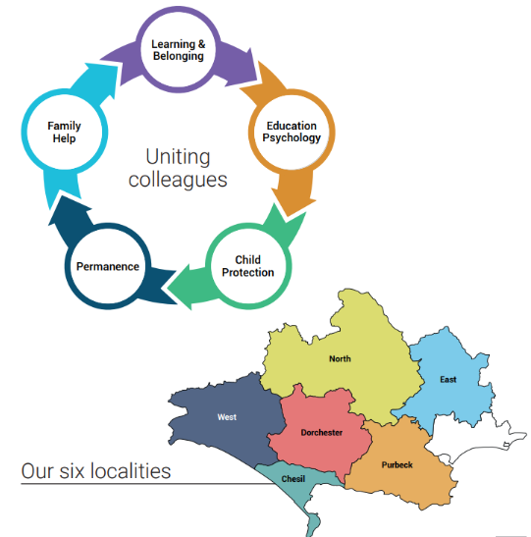

Travel requirement
This position has a significant travel requirement. This means that there is a requirement for a vehicle (or transport deemed to be suitable by the council) to be available at all times in order to carry out normal duties. Employees in positions with a significant travel requirement are required to provide a replacement vehicle if their usual vehicle is not available over an extended period.

Other information
The ability to converse at ease with officers across the council and external partners in accurate spoken English is essential for the post.

Context statement prepared by:
Clare Anderson | Date | July 2026

