

Applicant Information Pack

Assistant Headteacher

Contents

- Our Schools
- The local and surrounding area
- Person Specification
- Job Description
- Appointment and Remuneration
- Recruitment Privacy Notice



1 Our Schools

Wyke Regis Primary Federation was established in September 2010 bringing together Wyke Regis Infant School and Nursery and Wyke Regis CE Junior School under one Governing Body. The schools are located on adjacent sites with generous and attractive grounds.

As a Federation, the schools have one Head of Federation, one Deputy Head of Federation, one Inclusion Manager and one Governing Body. Each school also has a non-teaching Assistant Head and a School Business Manager.

Wyke Regis
CE Junior School

The school caters for children aged between 7 to 11 years of age. The premises consist of twelve classrooms, a library, a large practical/resource area, a fully equipped ICT suite, a hall, with adjoining drama/music studio and three Learning Bases.

There are two play areas used for playtimes, including a sports MUGA and there is a large playing field for sporting activities.

As a Church of England Voluntary Controlled school, the school has close links with All Saints Church which is the parish church.

The school is a 3 form entry school with the majority of children progressing from Wyke Regis Infant School. The Junior School is also above average in size with an admission number (PAN) of 360.

The school is organised into 4 year groups, with 3 classes in each year group. Each year group is currently led by a Year Leader. Year Leaders have responsibility for pastoral care and the organisation of curriculum within their year group and form our MLT.

Current Ofsted grade Good April 2022
Wyke Regis
Infant School and Nursery

The school is a Community Infant School and caters for children aged between 3 and 7 years age.

The school’s nursery class offers part time nursery education. There are places for up to 26 children at each session. Currently each child can attend for up to 15 or 30 hours free a week, depending on whether they qualify for the extra hours of Government funding. The nursery is a self-contained unit with its own entrance, a large classroom, a kitchen area, toilets and a secure outdoor play area.

The school is a 2 form entry school, which is above average in size with an admission number (PAN) of 180. Each class base has a classroom, an annexe for small group activities, and a large art and craft area.

All classes have an outside learning area as well as sharing extensive grassed and hard surface play areas. The school’s accommodation also includes a large hall, library area and a Nurture Room.

The school is organised into 3 year groups with three year leaders forming our MLT.

Current Ofsted grade Good May 2025

3. The Area

1. THE COUNTY OF DORSET


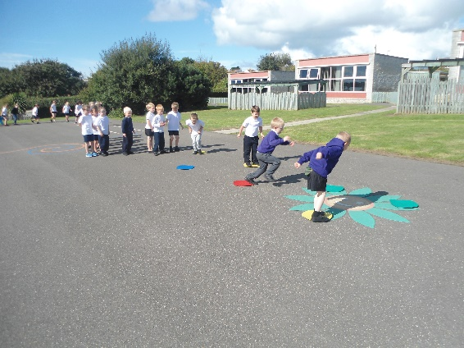
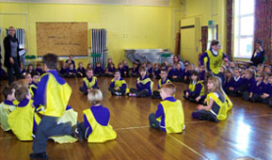

2 The local and surrounding area

The Federation schools are located in the village of Wyke Regis, part of the south western suburbs of Weymouth, on the northern shore of Portland Harbour, where the National Sailing Academy (host of the 2012 Olympic sailing events) is located and at the south eastern end of the world famous Jurassic Coast.

POPULATION STATISTICS

Dorset stretches from Lyme Regis in the west to Christchurch in the east and as far north as Sherborne and Gillingham. The greater part of the county is rural with many small villages and a few small towns. After Bournemouth and Poole, Weymouth is the largest settlement in Dorset. The most recent data records the County population at 754,460. The latest population for the Borough of Weymouth and Portland is recorded as 65,130 of which 16.5% are aged 0–15 years.

THE AREA

Wyke Regis has its own charter, granted in 988, and is proud of its past history and present growth. It is a close community and, although spreading outwards, the ethos of the area is much determined by the Old Village at its centre.

THE COMMUNITY

The Federation Friends Association organise regular functions for pupils and members of the community. In addition, parents are encouraged to be actively involved within the Federation schools. The children are considered to have an important part to play in the running of the school. Each school has a School Council which has taken a leading role in the school improvement process.

We work collaboratively with other local primary schools; links are also well established in the wider local community with the schools taking part in many events and festivals.

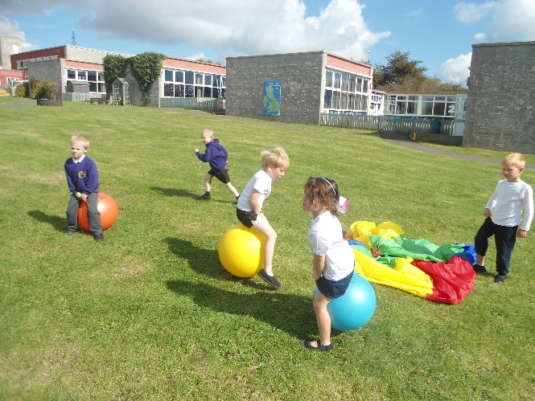
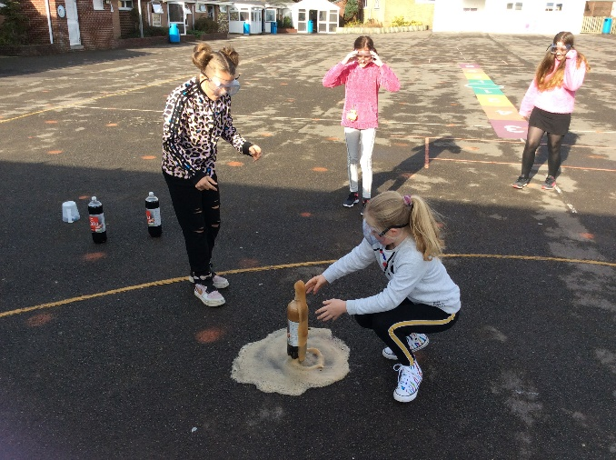

3 Person Specification – Assistant Headteacher

Education and Training | Essential | Desirable
Be a qualified teacher
Have achieved additional qualifications e.g., NPQBC, NPQSL
Evidence relevant and recent CPD, including Safeguarding
Experience | Essential | Desirable
Be a middle leader with some experience of work as part of a leadership team
Teaching experience within primary education for a minimum of 6-8 years
Demonstrate a clear vision for the implementation of the curriculum
Evidence sustained impact on standards and achievement as part of a team at whole school level
Evidence the ability to lead an aspect of improvement
Able to analyse and interpret school data effectively and implement key actions for improvement
Able to use school self-evaluation processes effectively to improve standards and can evidence contribution to this process
Able to demonstrate clear understanding of the needs of all groups of learners including SEND and disadvantaged pupils
Experience of managing and supporting staff to improve outcomes for pupils
Practical experience of links with other schools, educational establishments and the wider community to support transition and enhance teaching and learning
Effectively promote professional working relationships with parents and carers to enhance learning
Confidence to positively manage and encourage change
Leadership Skills | Essential | Desirable
Passion for education and the ability to lead and inspire people in order to develop high quality outcomes for pupils
Ability to manage a variety of people and situations effectively and sensitively
Lead staff training confidently
Plan, organise and evaluate the work of a school and prioritise areas for development as part of an SLT
Ability to work strategically and collaboratively with senior and middle leaders
Confidence and commitment to direct, delegate, develop and empower others
Demonstrate a commitment to engage with the community

Communication Skills | Essential | Desirable
Excellent communication skills, both verbal and written
Chair meetings effectively
Ability to use a variety of media competently, including IT as a day to day tool
Negotiate and consult effectively with others
Self-Management | Essential | Desirable
Work under pressure, meet deadlines, prioritise and manage own time effectively
Achieve challenging professional goals, taking responsibility for own professional development
Be highly organised, able to balance the demands of a busy school environment in a timely manner
Be an excellent role model in appearance, punctuality and manner
Teaching and Learning | Essential | Desirable
Be an outstanding teacher with a proven track record
Proven ability to develop an aspect of high quality teaching and learning across the school as part of the SDP in order to improve outcomes for children
Knowledge of statutory requirements and the ability to ensure delivery within a broad, balanced, relevant and differentiated curriculum to support all groups of children to achieve
Commitment to the positive management of behaviour
Knowledge of effective strategies for teaching pupils with SEN
Knowledge of effective strategies to raise attainment for disadvantaged pupils
Personal Attributes | Essential | Desirable
Adaptability to changing circumstances and new ideas
Commitment to follow tasks through to completion
Work as part of a team, both within the federation and with other agencies
Confident to lead by example, motivating and inspiring pupils, staff and parents
Be loyal, reliable and trustworthy with an ability to build strong professional relationships

4 Job Description - Assistant Headteacher

Terms & Conditions Nationally agreed terms and conditions apply

Accountable to Head of Federation

Manages All professional and associate staff day to day at the junior site. Direct responsibility for line management of teachers and therefore subject leaders and their responsibilities. Direct line management of the Middle Leadership Team (MLT) which includes work across the Federation at the Infant site.

The Assistant Head, working with and advising the Head and Deputy Head of Federation, is responsible for ensuring continuous improvement in standards of teaching, learning and welfare throughout the school. The Assistant Head has a key role to play in the day to day management and organisation of the school staff, pupils and resources. The developing and sustaining of effective relationships with parents/carers is a key aspect of the role.

The Leadership & Management

The Assistant Headteacher will:
- Work with the Head of Federation and Deputy Head of Federation to ensure the highest priority is given to safeguarding and promoting the welfare of children within the school with the responsibility of DSL.
- Implement and monitor strategies which secure high standards of behaviour and attendance, working with external professionals and the Locality team where appropriate. This includes managing the caseload for the Parent Liaison Officer.
- Motivate and work with others to create a shared culture and positive ethos in which supporting and challenging leads to improved outcomes for all pupils.
- In conjunction with the Head and Deputy Head of Federation, manage and organise the school environment efficiently and effectively to ensure that it meets both the needs of the curriculum and health and safety regulations.
- Maintain personal teaching expertise and share this with teachers and other staff.
- As a member of the Federation’s Senior Leadership Team, contribute to the planning, implementation and monitoring of the Federation and school improvement strategies including the FDP and SEF.
- Take a leading role in performance management of teachers throughout the school.
- Take responsibility for arranging and monitoring work experience and ITT placements.
- Ensure that resources, including staff are fully utilised to raise standards for pupils.
- Develop and extend the understanding of a range of learning needs, promoting strategies that ensure pupil progress for all groups of children.
- Work closely with the SENDCO to promote Inclusion strategies and effective intervention for those pupils with SEN, assisting with the Inclusion workload at the junior site.
- Lead weekly collective worship and promote the core values of the school to pupils & staff.
- Attend meetings of the Governing Body and their committees and support the Friends Association events/meetings as required.
- Establish and maintain effective relationships with parents and be pro-active in developing home-school links, working closely with the Federation Parent Liaison Officer.
- Promote high standards of staff attendance and punctuality; ensuring that appropriate administrative support is in place to support teacher effectiveness.
- Take the lead role in attending Child in Need (CIN), Child Protection (CP) and review meetings; being proactive in communicating with Children Services as necessary.

Teaching and Learning

The Assistant Headteacher will:
- Be an exemplar of good classroom practice in terms of planning, delivery, differentiation, assessment and record keeping.
- Promote a learning culture led by high expectations and aspirations for all pupils.
- Monitor the quality of curriculum provision through pupil’s work and teacher planning.
- Monitor, evaluate and review classroom practice and promote improvement strategies.
- Challenge under-achievement at all levels and ensure effective follow-up; communicating with the Head and Deputy Head of Federation as appropriate.
- Contribute to a culture and ethos of challenge and support where all pupils can achieve success and become engaged in their own learning.
- Ensure that the learning environment promotes a love of learning and also serves to raise the levels of attainment and achievement for all learners.
- Support teachers and TAs with appropriate strategies and planning in order to meet the needs of pupils with SEND, LAC and EAL, or those who are vulnerable/disadvantaged (PP).
- Provide classroom cover for colleagues as appropriate to promote the development and role of middle leaders.
Recording & Assessment

The Assistant Headteacher will:
- Set targets for raising achievement for all groups of pupils with the SLT, reporting and presenting information to stakeholders where necessary.
- Monitor the progress of all groups of pupils regularly through Arbor.
- Ensure a consistent and continuous focus on pupil achievement, using data and benchmarks to monitor progress.
- Support teachers in making judgements and recording assessments in core subjects.
- Monitor the impact of ‘Assessment for Learning’ in pupils’ work and teacher planning.
- Ensure that wider curriculum assessment strategies are consistently used and impactful.

Supporting the Efficiency and Effectiveness of the Federation

The Assistant Headteacher will:
- Support the aims and ethos of the Federation as set out in the Vision & Values document.
- Set an outstanding example in terms of punctuality, attendance and professional behaviour.
- Create and maintain an effective partnership with parents/carers to support and improve pupils’ achievement, personal development and attendance.
- Attend and support parental consultations/open evenings.
- Foster a positive environment which encourages, reinforces and supports appropriate and positive behaviour as well as responsibility, mutual respect and self-discipline.
- Participate in and lead staff training sessions.
- Attend all SLT and wider staff meetings, including across the Federation.
- Develop strong links with Governors, LA personnel, Chesil Collaboration schools/colleagues, parents/carers, the wider community and other stakeholders.

This job description may be amended at any time after discussion with the Head of Federation, but will be reviewed annually when key tasks related to the Federation’s priorities are determined. The Assistant Headteacher will be required to carry out a full range of professional duties set out in the relevant paragraphs of the current edition of the DfE School Teachers Pay and Conditions Document.

5 Appointment and Remuneration

How to Apply
Your completed application form must be submitted by the submission date. Interviews will be held following the shortlisting process and candidates will be informed by telephone and e-mail. Your supporting statement should detail your motivation for applying for this position. Decisions regarding the short-list will be made with reference to the person specification and job description.
NB: All applicants are required to complete the Dorset Council application form. We do not accept CVs in place of an application form.
Selection Process
The selection process will be undertaken by the Wyke Regis Primary Federation Senior Leadership Team (SLT) with members of the governing body who are committed to selecting excellent and motivated individuals to become part of our outstanding team to take our Federation forward.
If you require any further information, please contact Mrs Wanda Roberts, Head of Federation.
Any offer of employment made will be subject to receipt of satisfactory references, and positive responses to other pre-employment checks regarding your suitability for appointment.
Further details of the recruitment process and our Information Management and Data Protection procedures are contained in Recruitment Privacy Notice overleaf.
Salary
Salary is Leadership Pay Scale 4-8. The Terms and Conditions of employment will be in accordance with the NJC Agreement of Pay and Conditions of Service for Local Government Services (Green Book).
Visits
Visits to the schools are warmly welcomed and encouraged. Should you wish to visit please contact the school office.

Wyke Regis CE Junior School
High Street
Wyke Regis
Weymouth
Dorset
DT4 9NU

Tel: 01305 786041
Email: junoffice@wykeregisfed.dorset.sch.uk

website: www.wykeregisfed.dorset.sch.uk

6 Recruitment Privacy Notice

Wyke Regis Infant School and Nursery and Wyke Regis CE Junior School (collectively referred to as Wyke Regis Primary Federation) are the data controllers for the information you provide during the recruitment and selection process unless otherwise stated.

What will we do with the information you provide to us?

The information you provide during the process will only be used for the purpose of progressing your application, or to fulfil legal or regulatory requirements.

We will not share any of the information you provide during the recruitment and selection process with any third parties or store any of your information outside of the European Economic Area. The information you provide will be held securely by us and/or our data processors whether the information is in electronic or physical format.

We will use the contact details you provide to us to contact you to progress your application. We will use the other information you provide to assess your suitability for the role you have applied for.

What information do we ask for, and why?

We do not collect more information than we need to fulfil our stated purposes and will not retain it for longer than it is needed.

The information we ask for is used to assess your suitability for employment. You do not have to provide what we ask for but it might affect your application if you do not.

Application stage

We ask you for your personal details including name and contact details. We will also ask you about your previous experience, education, referees and for answers to questions relevant to the role you have applied for.

You will also be asked to provide equal opportunities information. This is not mandatory information – if you do not provide it, it will not affect your application. Any information provided during the online application process is not provided to the school. Any information you do provide will be provided to and used by Dorset Council only to produce and monitor equal opportunities statistics.

Conditional offer

If a conditional offer of employment is made to you, we will ask you for information so that we can continue our pre-employment checks. You must successfully complete pre-employment checks to progress to a final offer.

We are required to confirm the identity of our staff, their right to work in the United Kingdom and seek assurance as to their trustworthiness, integrity and reliability.
You will therefore be required to provide:
- Proof of your identity – you will be asked to present original documents, which we will photocopy.
- Proof of your qualifications – you will be asked to present original documents, which we will photocopy.
- You will be asked to complete a criminal records declaration (Form HR14) to declare any unspent convictions.

The email address you provide will be used by the employing school to contact you to complete an application for a Criminal Record check via the Disclosure and Barring Service.

We will contact your referees, using the details you provide in your application, directly to obtain references.

Occupational Health

If we make you a conditional offer, we will ask that you complete a short questionnaire that will help to determine if you are fit to undertake the work that you have been offered, or advise us if any adjustments are needed to the work environment or systems so that you may work effectively.

Should further consideration be required regarding your fitness for work, you may be asked to complete a pre-employment questionnaire. The information you provide will be forwarded unopened to Dorset Council’s Occupational Health Team who will provide us with a fit to work certificate or a report with recommendations. You are able to request to see the report before it is sent to us. If you decline for us to see it, then this could affect your job offer. If an occupational health assessment is required, this is likely to be carried out by Dorset Council’s Occupational Health Team or on occasion OH Assist, the County Council’s external occupational health specialists.

Their privacy notice can be viewed at: http://www.ohassist.com/privacy-policy/

Once all pre-employment checks have been satisfactorily completed and we make a final offer of employment, we will also ask you for the following:
Bank details – to process salary payments
Emergency contact details (NoK) so we know who to contact in case you have an emergency at work

Personnel Records

If you accept the final offer from us, your electronic personnel records will be held on SIMS, Dorset Council’s approved Management Information System provided under licence by Capita plc.

Your personnel records will also be held on SAP which is the records system used by Dorset Council Human Resources Department on our behalf for the purposes of payroll and the retention of data about your employment.

Their privacy notice can be review at:

https://www.sap.com/corporate/en/legal/privacy.html

Retention of Information

If you are successful, the information you provide during the application process will be retained by the school as part of your employee file for the duration of your employment plus 6 years following the end of your employment.

If you are unsuccessful at any stage of the process, the information you have provided until that point will be retained for 6 months from the closure of the recruitment and selection process.

Information generated throughout the assessment process, for example interview notes, is retained by us for 6 months following the closure of the recruitment and selection process.

Equal opportunities information is retained for 6 months following the closure of the recruitment and selection process whether you are successful or not.

Your rights

Under the General Data Protection Regulation, you have rights as an individual which you can exercise in relation to the information we hold about you.

You can read more about these rights here –

https://ico.org.uk/for-the-public/is-my-information-being-handled-correctly/

Complaints or queries

Wyke Regis Primary Federation tries to meet the highest standards when collecting and using personal information. For this reason, we take any complaints we receive about this very seriously.

We encourage people to bring it to our attention if they think that our collection or use of information is unfair, misleading or inappropriate. We would also welcome any suggestions for improving our procedures.

This privacy notice was drafted with brevity and clarity in mind. It does not provide exhaustive detail of all aspects of the Federation’s collection and use of personal information.

However, we are happy to provide any additional information or explanation needed. Any requests for this should be sent to the address below.

If you want to make a complaint about the way we have processed your personal information, you can contact the Data Controller at the school concerned:

Wyke Regis CE Junior School
High Street
Wyke Regis
Weymouth
Dorset
DT4 9NU

Access to personal information

Wyke Regis Primary Federation tries to be as open as it can be in terms of giving people access to their personal information. Individuals can find out if we hold any personal information by making a ‘subject access request’ under the Data Protection Act 1998 and General Data Protection Regulations.

If we do hold information about you, we will:

give you a description of it;
tell you why we are holding it;
tell you who it could be disclosed to; and
let you have a copy of the information in an intelligible form.

To make a request for any personal information we may hold you need to put the request in writing addressing it to our Data Controller or writing to the address provided above.

If you agree, we will try to deal with your request informally, for example by providing you with the specific information you need over the telephone.

If we do hold information about you, you can ask us to correct any mistakes by, once again, contacting the Data Controller at the school.



